**2015**

©2015 RTC:Rural. Our research is supported by CDC grant #1U59DD000991-01 from the Centers for Disease Control and Prevention. Opinions expressed are the author’s and do not necessarily reflect those of the funding agency.

**Montana Mammography Directory**

# ACKNOWLEDGEMENTS

We gratefully acknowledge the Montana Breast Cancer Resource Guide Committee for sharing information and ideas for the Montana Mammography Directory. We also acknowledge the Montana Affiliate of Susan G. Komen for the Cure, the Idaho and Montana Cancer Control Programs and the Centers for Disease Control and Prevention for their pioneering work in breast health education for women living with disability and for sharing information for the production of this Directory.

Finally, our sincere thanks go to our Volunteers, Disability Advocates, and Mammography Facility staff members without whose assistance and sharing of their expertise the Directory would not have been possible.

Disclaimer: Every attempt has been made to make this guide as inclusive as possible. No resource in this guide is required to pay for its listing. All information has been provided by the individual resource, and its inclusion in this guide does not imply endorsement by mammography clinics. Non-inclusion does not imply any judgment of the merit of the resource.

Table of Contents

**ACKNOWLEDGEMENTS** 1

**Table of Contents** 2

**Definitions of Terms** 4

**Key to Disability Access Terms** 7

**Right to Know Tip Sheet** 9

**BREAST CANCER** 9

**GETTING SCREENED** 9

**3D Mammography of Southwest MT, Inc.** 12

**Advanced Imaging of Montana on North Reserve** 13

**Advanced Imaging of Montana** 14

**Advanced Medical Imaging** 15

**Anaconda Community Hospital** 16

**Barrett Hospital & Healthcare** 17

**Beartooth Billings Clinic** 18

**Benefis Hospital at South Towers** 19

**Big Horn Hospital Association** 20

**Billings Clinic Miles City** 21

**Billings Clinic Center for** 22

**Breast Health** 22

**Billings Clinic West** 23

**Blackfeet Community Hospital** 24

**Broadwater Health Center** 25

**Cabinet Peaks Medical Center** 26

**Central Montana Medical Center** 27

**Clark Fork Valley Hospital** 28

**Crow-Northern Cheyenne Hospital** 29

**Deer Lodge Medical Center** 30

**Eureka Health Prompt Care** 31

**Fallon Medical Complex** 32

**Frances Mahon Deaconess Hospital** 33

**Fort Belknap Center IHS** 34

**Glendive Medical Center** 35

**Great Falls Clinic Medical Center** 36

**Helena Imaging Center** 37

**Holy Rosary Healthcare** 38

**Liberty Medical Center** 39

**Livingston HealthCare** 40

**Marcus Daly Memorial Hospital** 41

**Marias Medical Center** 42

**Mineral Community Hospital** 43

**Missouri River Medical Center** 44

**Northern Rockies Medical Center** 45

**North Valley Hospital** 46

**Northeast Montana Health Services** 47

**Northern Montana Hospital** 48

**Phillips County Hospital & Family Health Clinic** 49

**Polson Health** 50

**Pondera Medical Center** 51

**St. Vincent Mobile** 52

**St. James Healthcare Imaging Services** 53

**Providence St. Joseph Medical Center** 54

**St. Luke Community Healthcare** 55

**St. Peter’s Maria Dean Hospital** 56

**Sheridan Memorial Hospital** 57

**Sidney Health Center** 58

**Stillwater Community Hospital** 59

**Teton Medical Center** 60

**Wheatland Memorial Health** 61

**Winkley Women’s Center** 62

**The Women’s Center at Healthcare Northwest** 63

**Yellowstone Breast Center** 64

# Definitions of Terms

**In the 2015 Montana Mammography Directory, the following terms are defined as:**

**Breast Cancer Support Group** –Peer or professionally-guided meetings for breast cancer survivors, people undergoing treatment for breast cancer, and their families.

**Breast Cancer Patient Navigator** – A navigator is a single point of contact for cancer patients and their families. The navigator is an educator, an advocate and a friend. The navigator is a specially trained professional who assists in all aspects of the patient’s care experience. When clinical issues arise, a navigator can refer patients to the appropriate healthcare provider office or other healthcare resource.

**Breast Prosthetics** – Artificial substitute for an absent breast.

**Breast Reconstruction** –Surgical reconstruction of a breast after removal of breast tissue.

**Breast Self-Examination (BSE)** –A technique to examine one’s own breasts by looking and feeling for changes. BSE is a tool that can be used to both increase awareness of breast cancer and to learn about what changes in the breast should be reported. BSE is recommended beginning at age 20.

**Breast Tomosynthesis (**three-dimensional **(3D) mammography)** and digital breast tomosynthesis (DBT), is an advanced form of breast imaging where multiple images of the breast from different angles are captured and reconstructed ("synthesized"”) into a three-dimensional image set. In this way, 3D breast imaging is similar to computed tomography (CT) imaging in which a series of thin "slices" are assembled together to create a 3D reconstruction of the body.

**Chemotherapy** –Treatment of cancer with certain drugs that destroy cancer cells.

**Clinical Breast Exam** –Examination of the breasts and surrounding area by a trained healthcare provider.

**Clinical Trials** – Carefully designed and monitored studies of new methods for treating or preventing cancer.

**Complementary Therapies** –Treatments such as acupuncture, chiropractic, homeopathy, massage, meditation, art, dance, or nutrition which may reduce stress and/or boost the immune system. Often used along with traditional medical treatment.

**Computerized Tomography (CT)** – Cross-sectional x-rays that detect or monitor tissue abnormalities.

**Contract Radiologist** – Radiologist services provided under facility contract. Generally used for facilities that may not have on-site radiologists available on a full or part-time basis.

**Computer Assisted Device (also known as Computer Aided Detection)** –Computerized algorithms that assist the radiologist in identifying types of breast tissue.

**Core Needle Biopsy** – Core needle biopsy uses a thin, hollow needle to remove samples of tissue from the breast. It can be used on suspicious areas that can be felt (palpable masses) and those that can only be seen on a mammogram or other imaging test (nonpalpable masses).

**Counseling** –Treatment of emotional discomfort through the use of psychological techniques that encourage communication of conflict, insight into problems and personal growth.

**Dual Energy X-ray Absorptiometry (DXA, previously DEXA)** – is a means of measuring bone mineral density (BMD).

**Digital Mammography Machine** – Newer full-field digital mammography units capture the picture on an electronic digital detector, and the image is then displayed on a video monitor. Digital mammography also offers the advantages that images can be stored and retrieved easily and transmitted electronically for review by another radiologist.

**Financial Assistance** –Direct assistance or referral to appropriate sources, which may provide financial counseling or direct monetary support for medical procedures and treatments.

**Film (“Analog”) Mammography Machine** –A machine that produces a black and white x-ray picture of the breast tissue. Today, many mammography units are screen-film units, which mean they produce the mammography picture on x-ray film.

**Fine Needle Aspiration/Biopsy** – Fine needle aspiration (also known as fine needle biopsy) is a needle biopsy that removes cell samples rather than tissue samples from an abnormal area of the breast.

**Galactograms** –Galactography is an x-ray examination that uses mammography and a contrast material to obtain pictures of the inside of the breast's milk ducts.

**Genetic Risk Counseling** –Education, information and discussion of genetic factors that may put certain family members at risk for inheriting the potential to develop breast cancer.

**Hospice** – A philosophy of delivery of care emphasizing comfort, peace of mind and control of symptoms, usually involved when life expectancy is short.

**Incisional Biopsy** –A biopsy in which only a sample of the suspicious tissue is cut into (incised) and removed for the purpose of diagnosis. An incisional biopsy is in contrast to an excisional biopsy in which an entire lesion, usually a tumor, is removed.

**Indian Health Services (IHS)** – Responsible for providing federal health services to American Indiansand Alaska Natives.

**Magnetic Resonance Imaging (MRI)** – A method of creating three-dimensional images of the body using a magnet and radio waves instead of x-rays.

**Mammogram (Diagnostic)** –Diagnostic mammography is an x-ray exam of the breasts that is performed in order to evaluate a breast complaint or abnormality detected by physical exam or routine screening mammography. Diagnostic mammography is different from screening mammography in that additional views of the breast are usually taken, as opposed to two views typically taken with screening mammography. Thus, diagnostic mammography is usually more time-consuming and more costly than screening mammography.

**Mammogram (Screening)** – An x-ray of the breast that includes two views and is used for comparison with previous and subsequent mammograms.

**Medicaid** –A federal program that reimburses hospitals and healthcare providers for providing health care to qualifying people who meet established financial criteria.

**Medicare** –Aprogram under the US Social Security Administration that reimburses healthcare providers and hospitals for health care provided to qualified patients 65 years or older or patients with a disability.

**Needle Localization** –A procedure that uses very thin needles or guide wires to mark the location of an abnormal area of tissue so it can be surgically sampled. An imaging device such as an ultrasound probe is used to place the wire in or around the abnormal area. Needle localization is used when the healthcare provider cannot feel the mass of abnormal tissue.

**Physical Therapy** –Treatment by physical methods such as massage and exercise; treatment of injury to restore strength and range of motion.

**Positive Emission Tomography (PET) Scan** –A nuclear medical imaging technique that produces a three-dimensional image or picture of functional processes in the body.

**Provide A Referral** –Some mammography centers allow women to self-order a mammogram. They will require that the patient provide them with the name of a healthcare provider who will receive the test results and follow up on any abnormalities. Other centers require an order from a healthcare provider in order to do the mammogram.

**Radiation Therapy** –Treatment by x-ray machines to deliver high-energy radium or cobalt used to reduce the size of tumors.

**Referral** –Directing individuals to service providers such as specialists or support groups.

**Second Opinion** –Examination of a patient or a patient’s records by a second physician for treatment recommendations.

**Stereotactic Biopsy** – Removal of small samples of breast tissue for microscopic evaluation using a hollow (core) needle which is precisely guided to the correct location via x-rays and computer coordinates.

**Transportation** – Assistance to and from medical and support systems.

**Tumor Board** – A panel of experts in radiology, oncology, surgery, and pathology that makes treatment recommendations.

**Tumor Registry** – A system designed for the collection, management and analysis of information about patients with a cancer diagnosis.

**Ultrasound (Sonogram)** –Non-invasive medical imaging that uses high-frequency sound waves to generate images of breast masses.

# Key to Disability Access Terms

**The information about disability access for each facility is based on the following definitions:**

**BUILDING ACCESS**

**Standard Accessible Parking**

* A parking space that is at least eight feet wide
* With an adjoining access aisle at least five feet wide
* With signage displaying the international symbol of accessibility

**Van Accessible Parking**

* A parking space that is at least eight feet wide
* With an adjoining access aisle at least eight feet wide
* With signage displaying the international symbol of accessibility and the words   
  “Van Accessible”

**Accessible Exterior Route and Doors**

**The path from parking and pedestrian walkways to the building entrance has**

* A slope of 1:20 or less (No more than one inch of vertical rise for every 20 inches of horizontal rise)
* A minimum clear width of 36” for the entire route of travel
* A stable, firm, and slip resistant pathway
* Ramped curb cuts at the curbs
* Ramps or other means of access provided where there are level changes greater than ½”
* No protruding objects that reduce the clear width of travel

**Accessible Building Entrance, Exterior Door**

* Doorway at least 32 inches wide
* Handle that can be used with a closed fist. For example, a lever handle is usable; a round doorknob is not usable.
* Requires no more than 15 lbs of force to open

**ACCESSIBLE INTERIOR PATH**

**The paths to the waiting area, restrooms, and program areas have**

* Stable, firm, slip-resistant surfaces
* A minimum clear width of 36” for the entire route of travel
* Ramps or other means of access provided where there are level changes greater than ½”
* No protruding objects that reduce the clear width of travel

**Accessible Interior Doors, defined as**

* Doorway at least 32 inches wide
* Handle that can be used with a closed fist. For example, a lever handle is usable; a round doorknob is not usable.
* Requires no more than 5 lbs of force to open

**ACCESSIBLE MAMMOGRAPHY ROOM**

**Accessible Doors**

* Doorway at least 32 inches wide
* Handle that can be used with a closed fist. For example, a lever handle is usable; a round doorknob is not usable
* Requires no more than 5 lbs of force to open

**Accessible Route and enough space to move around machine**

* Is on an accessible route
* Stable, firm, slip resistant surfaces
* A minimum clear width of 36” for the entire route of travel
* No protruding objects that reduce the clear width of travel
* A T-shaped clear floor space or one that is 60” in diameter for a wheelchair to make a 180° turn on the side of the mammography machine with the x-ray plate

**Lowest Height of the x-ray plate from the floor**

* Distance from the floor to the top of the x-ray plate (number of inches)
* The closer to the floor the plate can be lowered, the more easily a seated woman can be accommodated.

**ACCESSIBLE RESTROOM**

**Accessible Doors**

* Doorway at least 32 inches wide
* Handle that can be used with a closed fist. For example, a lever handle is usable; a round doorknob is not usable.
* Requires no more than 5 lbs of force to open

**Accessible Route and Turning Space**

* A T-shaped clear floor space or one that is 60” in diameter for a wheelchair to make a 180° turn OR a five by six foot accessible stall
* Toilet is located on the 60” wall
* At least 42” clear floor space from the center line of the toilet to the wall

**Accessible Toilet, Fixtures and Sink**

* Toilet seat measures 17 to 19 inches high
* Horizontal grab bars 1 ¼ to 1 ½ inch in outside diameter securely mounted at the near side wall and rear of toilet
* Toilet paper dispenser mounted on side wall closest to the toilet at least 24 inches above the floor
* Sink handles that can be used with a closed fist
* At least 27 inches of knee clearance below the bottom of the sink

# Right to Know Tip Sheet

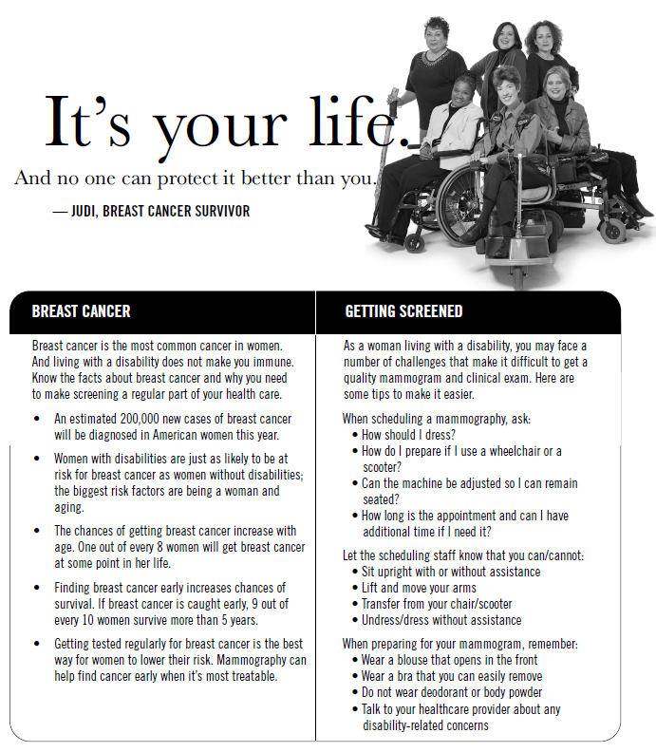



|  |  |
| --- | --- |
| **BREAST CANCER** | **GETTING SCREENED** |
| Breast cancer is the most common cancer in women. And living with a disability does not make you immune. Know the facts about breast cancer and why you need to make screening a regular part of your health care. | As a woman living with a disability, you may face a number of challenges that make it difficult to get a quality mammogram and clinical exam. Here are some tips to make it easier. |
| * An estimated 234,000 new cases of breast cancer will be diagnosed in American women this year. * Women with disabilities are just as likely to be at risk for breast cancer as women without disabilities; the biggest risk factors are being a woman and aging. * The chances of getting breast cancer increase with age. One out of every 8 women will get breast cancer at some point in her life. * Finding breast cancer early increases chances of survival. If breast cancer is caught early, 9 out of every 10 women survive more than 5 years. * Getting tested regularly for breast cancer is the best way for women to lower their risk. Mammography can help find cancer early when it’s most treatable. | When scheduling a mammography, ask:   * How should I dress? * How do I prepare if I use a wheelchair or a scooter? * Can the machine be adjusted so I can remain seated? * How long is the appointment and can I have additional time if I need it?   Let the scheduling staff know that you can/cannot:   * Sit upright with or without assistance. * Lift and move your arms. * Transfer from your chair/scooter. * Undress/dress without assistance.   When preparing for your mammogram, remember:   * Wear a blouse that opens in the front * Wear a bra that you can easily remove * Do not wear deodorant or body powder * Talk to your healthcare provider about any disability-related concerns |

**If you are 40 to 49 years old, talk to your doctor about getting a mammogram.**

**If you are 50 or older, be sure to get a mammogram every two years. For more information, visit www.cdc.gov/RightToKnow or call 1-800-CDC-INFO (232-4636); 1-888-232-6348 (TTY).**



The mission of the Montana Cancer Screening Program is to reduce   
breast and cervical cancer deaths among Montana women by providing ongoing quality   
screening services and education in a manner that is appropriate, accessible,   
cost-effective and sensitive to women's needs.

The Montana Cancer Screening Program provides mammograms, clinical   
breast exams, Pap tests and pelvic exams for the early detection of breast and   
cervical cancer. These services may be provided [free to eligible women.](http://www.dphhs.mt.gov/PHSD/cancer-control/documents/CurrentIncomeGuidelines_001.pdf)

For information about low cost or free Mammograms and Pap Tests,

**Call Toll Free**

**1-888-803-9343**



# Montana Cancer

# Control Programs

**Breast Cancer and Women with Disabilities**

Women in the United States get breast cancer more than any other type of cancer except for skin cancer.1 In Montana, an average of 800 women are diagnosed with breast cancer each year.2  Breast cancer screening means checking a woman's breasts for cancer before there are signs or symptoms of the disease. Doctors recommend that women have regular clinical breast exams and mammograms to find breast cancer early. When abnormal tissue or cancer is found early, it may be easier to treat.1

Breast cancer is a major public health concern for all women, including women with disabilities. In the U.S., women who have disabilities are just as likely as women without disabilities to have ever received a mammogram. However, they are significantly less likely to have been screened within the recommended guidelines.3 Barriers to screening include: thinking “it won’t happen to me”; focusing on other health issues; difficulty with positioning while getting a mammogram; not knowing where to go for accessible screening; inaccessible facilities and equipment; and the provider’s knowledge and attitudes.3 Providers should ensure that they are not only treating a woman’s disability, but are regularly addressing screening for breast cancer and other conditions for which screening is recommended.

**Tips to Increase Breast Cancer Screening Rates for Women with Disabilities**

* Train scheduling staff, radiologic technologists and providers on appropriate communication and screening techniques for women with disabilities. This training can ensure that more women are screened for breast cancer within the recommended guidelines.
* When scheduling a woman with a disability for breast cancer screening, it is often useful for staff to ask questions to determine what additional assistance or time may be needed to complete the screening test.
* Become familiar with methods to assist a person with a disability during an exam, to avoid embarrassment and frustration for both the patient and the staff member.
* The provider and patient should discuss specific needs and preferences during screening, such as assistance with undressing, seated mammograms, and additional time for appointments.
* Office staff and providers can create a practice that is physically accessible and accommodating for everyone, regardless of ability. A universally accessible practice may increase the likelihood that patients with disabilities will seek out and obtain regular preventive health care services.4
* Information in the document titled “Access to Medical Care for Individuals with Mobility Disabilities” can assist providers in understanding how to work with patients with disabilities, as well as determining how to make exam rooms and equipment accessible. <http://www.ada.gov/medcare_ta.htm>

1 National Cancer Institute. Breast Cancer Prevention PDQ® “General Information About Breast Cancer”

(Patient Version) [www.cancer.gov](http://www.cancer.gov)

2 Montana Central Tumor Registry Annual Report 2009

3 Centers for Disease Control & Prevention. The Right to Know Campaign (Overview) [www.cdc.gov](http://www.cdc.gov)

4 Adapted from The Center for Universal Design and The North Carolina Office on Disability and Health <http://www.fpg.unc.edu/~ncodh/rbar/>

**Montana Resources**

The Montana Disability and Health Program maintains a mammography directory,

which provides information on mammography service providers by city.  Each entry includes contact information, hours of operation, standard and additional services available, and disability access information.

The CDC created health promotion materials (e.g., posters, MP3 files, low-tech fliers, print advertisements,

and tip sheets) to increase awareness of breast cancer among women with physical disabilities and encourage these women to get screened. Materials share the tagline “Breast Cancer Screening. The Right to Know,” and feature four women with physical disabilities who have survived breast cancer.3

Free “Right to Know” materials are available online at

<http://www.cdc.gov/ncbddd/disabilityandhealth/righttoknow/>

**For information on free cancer screening services:**

**1-888-803-9343**

[www.cancer.mt.gov](http://www.cancer.mt.gov)

**Lisa Troyer**

**Section Supervisor**

1400 E. Broadway

Helena, Montana

59260-2951

(406) 444-6089



**3D Mammography of Southwest MT, Inc.**

**406-299-3302**

800 West Platinum, Unit D

Butte, MT 59701

**Hours: 8:00–5:00 PM; M-F**

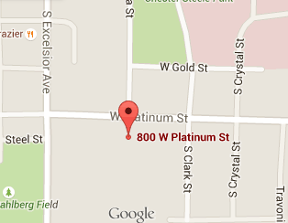

**General Information**

Standard cost for self-pay mammogram $270.00

Usual wait for a screening mammogram 1 day

Do patients need to provide a referral No

Type of mammography machines Digital; 3D

Radiologist On-site Part-time

Contract Radiologist Yes

**Facility Access Information**

**Van Accessible Parking Unknown**

**Standard Accessible Parking Unknown**

**Accessible Exterior Route Unknown**

Accessible path Unknown

Accessible doors Unknown

**Accessible Interior Route Unknown**

**Accessible Mammography Room Unknown**

Accessible doors Unknown

Accessible route and maneuvering space Unknown

Lowest height of x-ray plate from floor Unknown

**Accessible Restroom on Same Floor Unknown**

Accessible route and turning space Unknown

Accessible toilet, fixtures and sink Unknown

**Language/Alternative Communication**

**Spoken:** English

**Printed:** English

**Video**: N/A

**Braille:** No

**Large Print:** Yes

**Sign Language:** Limited

**Additional Services**

* Patient Information/Education
* Diagnostic Mammograms
* Located on a Bus Route
* Accepts Medicare/Medicaid

**Note**: The available information was gathered autumn 2016 and this facility did not receive an accessibility assessment nor interview. Please call the facility for current information.

When scheduling an appointment, notify the facility if you require accommodations.

Keys to symbols: ✝ Radiologist and/or Computer Assisted Device charges not included



**Advanced Imaging of Montana on North Reserve**

**406-327-3950**

3275 North Reserve

Missoula, MT 59808

**Hours: 8:00AM-5:00PM; Mon-Fri**

[www.advancedimagingofmt.com](http://www.advancedimagingofmt.com)

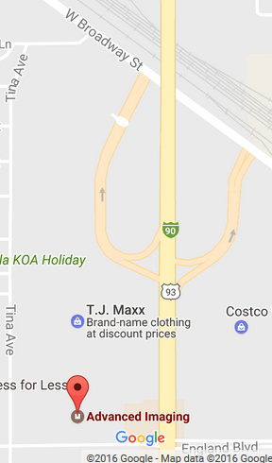

**General Information**

Standard cost for self-pay mammogram $268.50

Usual wait for a screening mammogram Same day/ Walk in

Do patients need to provide a referral No

Type of mammography machines Digital

Radiologist On-site Yes/Main Site

**Facility Access Information**

**Van Accessible Parking Yes**

**Standard Accessible Parking Yes**

**Accessible Exterior Route Yes**

Accessible path Yes

Accessible doors Yes

**Accessible Interior Route Yes**

**Accessible Mammography Room Yes**

Accessible doors Yes

Accessible route and maneuvering space Yes

Lowest height of x-ray plate from floor 31 inches

**Accessible Restroom on Same Floor Yes**

Accessible route and turning space Yes

Accessible toilet, fixtures and sink Yes

**Language/Alternative Communication**

**Spoken:** English, Spanish, Russian

**Printed:** English

**Video**: English

**Braille:** English

**Large Print:** English

**Sign Language:** Yes

**Additional Service**

* Reduced Rate Screening Mammograms
* Accepts Medicaid Patients
* Accepts Medicare Patients
* Information of the Internet
* Breast Cancer Patient Navigator
* Located on a bus route
* Offers transportation services

**Note**: The available information was gathered spring 2015. Some features including costs, may have changed. Please call the facility for current information.

When scheduling an appointment, notify the facility if you require accommodations.

Keys to symbols: ✝ Radiologist and/or Computer Assisted Device charges not included



**Advanced Imaging of Montana**

**406-327-3953**

2803 South Avenue

Missoula, MT 59804

**Hours: 7:00AM-5:30PM; Mon-Fri**

[www.advancedimagingofmt.com](http://www.advancedimagingofmt.com)

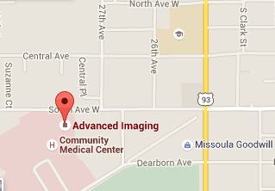

**General Information**

Standard cost for self-pay mammogram $268.50

Usual wait for a screening mammogram Same day/ Walk in

Do patients need to provide a referral No

Type of mammography machines Digital

Radiologist On-site Full-time

**Facility Access Information**

**Van Accessible Parking Yes**

**Standard Accessible Parking Yes**

**Accessible Exterior Route Yes**

Accessible path Yes

Accessible doors Yes

**Accessible Interior Route Yes**

**Accessible Mammography Room Yes**

Accessible doors Yes

Accessible route and maneuvering space Yes

Lowest height of x-ray plate from floor 31 inches

**Accessible Restroom on Same Floor Yes**

Accessible route and turning space Yes

Accessible toilet, fixtures and sink Yes

**Language/Alternative Communication**

**Spoken:** English, Spanish, Russian

**Printed:** English

**Video**: English

**Braille:** English

**Large Print:** English

**Sign Language:** Yes

**Additional Service**

* Reduced Rate Screening Mammograms
* Accepts Medicaid Patients
* Accepts Medicare Patients
* Information of the Internet
* Breast Cancer Patient Navigator
* Located on a bus route
* Offers transportation services
* CT
* MRI
* PET-CT

**Note**: The available information was gathered spring 2015. Some features including costs, may have changed. Please call the facility for current information.

When scheduling an appointment, notify the facility if you require accommodations.

Keys to symbols: ✝ Radiologist and/or Computer Assisted Device charges not included



**Advanced Medical Imaging**

**406-414-5200**

915 Highland Blvd. Suite 4100

Bozeman, MT 59715

**Hours: 7:00AM-7:00PM**

[www.amibozeman.com](http://www.amibozeman.com)

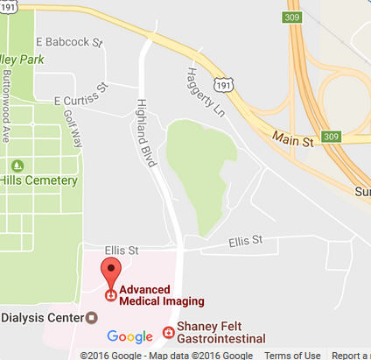

**General Information**

Standard cost for self-pay mammogram $265.00 ✝

Usual wait for a screening mammogram 3-5 days

Do patients need to provide a referral Yes

Type of mammography machines Digital

Radiologist On-site Full-time

**Facility Access Information**

**Van Accessible Parking Yes**

**Standard Accessible Parking Yes**

**Accessible Exterior Route No**

Accessible path Yes

Accessible doors No

**Accessible Interior Route Yes**

**Accessible Mammography Room Yes**

Accessible doors Yes

Accessible route and maneuvering space Yes

Lowest height of x-ray plate from floor 26 inches

**Accessible Restroom on Same Floor Yes**

Accessible route and turning space Yes

Accessible toilet, fixtures and sink Yes

**Language/Alternative Communication**

**Spoken:** English

**Printed:** English

**Video**: None

**Braille:** English

**Large Print:** English

**Sign Language:** No

**Additional Service**

* Reduced Rate Screening Mammograms
* Flat Screening Mammograms
* Accepts Medicaid Patients
* Accepts Medicare Patients
* Located on a bus route
* Breast Cancer Patient Navigator
* Diagnostic Mammograms
* Ultrasound/Sonogram
* CT
* MRI

**Note**: The available information was gathered spring 2015. Some features including costs, may have changed. Please call the facility for current information.

When scheduling an appointment, notify the facility if you require accommodations. Keys to symbols: ✝ Radiologist and/or Computer Assisted Device charges not included.



**Anaconda Community Hospital**

**406-563-8660**

401 West Pennsylvania

Anaconda, MT 59711

**Hours: 7:00AM-4:00PM**

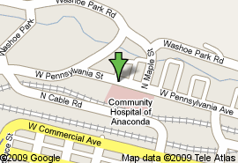

**General Information**

Standard cost for self-pay mammogram $186.00 ✝

Usual wait for a screening mammogram ½-1 day

Do patients need to provide a referral Yes

Type of mammography machines Digital

Radiologist On-site Part-time

**Facility Access Information**

**Van Accessible Parking Yes**

**Standard Accessible Parking Yes**

**Accessible Exterior Route Yes**

Accessible path Yes

Accessible doors Yes

**Accessible Interior Route Yes**

**Accessible Mammography Room Yes**

Accessible doors Yes

Accessible route and maneuvering space Yes

Lowest height of x-ray plate from floor 27 inches

**Accessible Restroom on Same Floor Yes**

Accessible route and turning space Yes

Accessible toilet, fixtures and sink Yes

**Language/Alternative Communication**

**Spoken:** English

**Printed:** English

**Video**: English

**Braille:** English

**Large Print:** No

**Sign Language:** No

**Additional Service**

* Accepts Medicaid Patients
* Accepts Medicare Patients
* Hospice
* Home Health Office
* Diagnostic Mammograms
* Ultrasound/Sonogram

**Note**: The available information was gathered spring 2015. Some features including costs, may have changed. Please call the facility for current information.

When scheduling an appointment, notify the facility if you require accommodations.

Keys to symbols: ✝ Radiologist and/or Computer Assisted Device charges not included



**Barrett Hospital & Healthcare**

**406-683-3266**

600 Highway 915

Dillon, MT 59725

**Hours: 8:00AM-6:00PM**

[www.barretthospital.org](http://www.barretthospital.org)

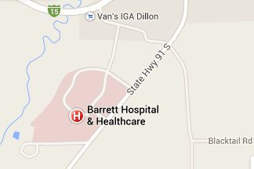

**General Information**

Standard cost for self-pay mammogram $250.00 ✝

Usual wait for a screening mammogram 1-2 days

Do patients need to provide a referral Yes

Type of mammography machines Digital

Radiologist On-site Part-time

(4 days per week)

**Facility Access Information**

**Van Accessible Parking Yes**

**Standard Accessible Parking Yes**

**Accessible Exterior Route No**

Accessible path No

Accessible doors Yes

**Accessible Interior Route Yes**

**Accessible Mammography Room Yes**

Accessible doors Yes

Accessible route and maneuvering space Yes

Lowest height of x-ray plate from floor 26 inches

**Accessible Restroom on Same Floor Yes**

Accessible route and turning space Yes

Accessible toilet, fixtures and sink Yes

**Language/Alternative Communication**

**Spoken:** English, Spanish

**Printed:** English, Spanish

**Video**: English

**Braille:** English

**Large Print:** English

**Sign Language:** No

**Additional Service**

* Reduced Rate Screening Mammograms
* Free Screening Mammograms
* Accepts Medicaid Patients
* Accepts Medicare Patients
* Diagnostic Mammograms
* CT
* Ultrasound/Sonogram
* Ultrasound-Guided Core Biopsy
* Lumpectomy/Mastectomy
* Sentinel Nodes Biopsy
* Excisional Biopsy
* Located on a bus route
* Offers transportation service
* Home Care/Hospice
* Breast Self-Exam Training
* Physical Therapy
* Lymphedema Specialty Services
* Referral Services
* Second Opinion
* Breast Cancer Group
* Family/Caregiver

**Note**: The available information was gathered spring 2015. Some features including costs, may have changed. Please call the facility for current information.

When scheduling an appointment, notify the facility if you require accommodations.

Keys to symbols: ✝ Radiologist and/or Computer Assisted Device charges not included



**Beartooth Billings Clinic**

**406-446-2345**

2525 North Broadway

Red Lodge, MT 59068

**Hours: 8:00AM-4:30PM**

[www.beartoothbillingsclinic.org](http://www.beartoothbillingsclinic.org)

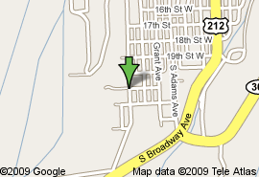

**General Information**

Standard cost for self-pay mammogram $219.40

Usual wait for a screening mammogram 1 day

Do patients need to provide a referral No

Type of mammography machines Digital

Radiologist On-site No

Contract Radiologist Yes

**Facility Access Information**

**Van Accessible Parking Yes**

**Standard Accessible Parking Yes**

**Accessible Exterior Route Yes**

Accessible path Yes

Accessible doors Yes

**Accessible Interior Route Yes**

**Accessible Mammography Room Yes**

Accessible doors Yes

Accessible route and maneuvering space Yes

Lowest height of x-ray plate from floor 18 inches

**Accessible Restroom on Same Floor Yes**

Accessible route and turning space Yes

Accessible toilet, fixtures and sink Yes

**Language/Alternative Communication**

**Spoken:** English

**Printed:** English

**Video**: None

**Braille:** English

**Large Print:** No

**Sign Language:** No

**Additional Service**

* Accepts Medicaid Patients
* Accepts Medicare Patients
* Diagnostic Mammograms
* Ultrasound/Sonogram
* PT
* Hospice
* Home Care
* Educational Materials
* Referral Services

**Note**: The available information was gathered spring 2015. Some features including costs, may have changed. Please call the facility for current information.

When scheduling an appointment, notify the facility if you require accommodations.

Keys to symbols: ✝ Radiologist and/or Computer Assisted Device charges not included



**Benefis Hospital at South Towers**

**406-731-8405**

South Tower 1101 26th Street South

Great Falls, MT 59405

**Hours: 8:00AM-4:00PM**

[www.benefis.org](http://www.benefis.org)

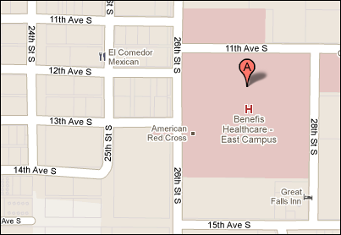

**General Information**

Standard cost for self-pay mammogram $150.00 ✝

Usual wait for a screening mammogram 1 week

Do patients need to provide a referral Yes

Type of mammography machines Digital

Radiologist On-site Full-time

**Facility Access Information**

**Van Accessible Parking Yes**

**Standard Accessible Parking Yes**

**Accessible Exterior Route Yes**

Accessible path Yes

Accessible doors Yes

**Accessible Interior Route Yes**

**Accessible Mammography Room Yes**

Accessible doors Yes

Accessible route and maneuvering space Yes

Lowest height of x-ray plate from floor 27 inches

**Accessible Restroom on Same Floor Yes**

Accessible route and turning space Yes

Accessible toilet, fixtures and sink Yes

**Language/Alternative Communication**

**Spoken:** English, Spanish

**Printed:** English

**Video**: None

**Braille:** No

**Large Print:** No

**Sign Language:** Yes

**Additional Service**

* Accepts Medicaid Patients
* Accepts Medicare Patients
* Diagnostic Mammograms
* Ultrasound/Sonogram
* MRI
* Information on internet
* Breast Cancer Patient Navigator
* Located on a bus route

**Note**: The available information was gathered spring 2015. Some features including costs, may have changed. Please call the facility for current information.

When scheduling an appointment, notify the facility if you require accommodations.

Keys to symbols: ✝ Radiologist and/or Computer Assisted Device charges not included



**Big Horn Hospital Association**

**406-665-2310**

17 North Miles

Hardin, MT 59034

**Hours: 8:00AM-5:00PM; M-F**

[www.bighornhospital.org](http://www.bighornhospital.org)

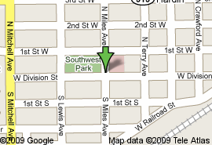

**General Information**

Standard cost for self-pay mammogram $288.00

Usual wait for a screening mammogram Same day

Do patients need to provide a referral Yes

Type of mammography machines Digital

Radiologist On-site No

Contract Radiologist Yes

**Facility Access Information**

**Van Accessible Parking Yes**

**Standard Accessible Parking Yes**

**Accessible Exterior Route Yes**

Accessible path Yes

Accessible doors Yes

**Accessible Interior Route Yes**

**Accessible Mammography Room Yes**

Accessible doors Yes

Accessible route and maneuvering space Yes

Lowest height of x-ray plate from floor 11 inches

**Accessible Restroom on Same Floor Yes**

Accessible route and turning space Yes

Accessible toilet, fixtures and sink Yes

**Language/Alternative Communication**

**Spoken:** English, Spanish, Other

**Printed:** English, Spanish

**Video**: English

**Braille:** No

**Large Print:** No

**Sign Language:** Yes

**Additional Service**

* Accepts Medicaid Patients
* Accepts Medicare Patients
* Free screenings
* Diagnostic Mammograms
* Ultrasound/Sonogram
* Complimentary Therapies
* Nutrition
* Video: Breast Self-Exam Training
* Patient Information/Education
* Breast Cancer Patient Navigator
* Second Opinion
* Transportation Services

**Note**: The available information was gathered spring 2015. Some features including costs, may have changed. Please call the facility for current information.

When scheduling an appointment, notify the facility if you require accommodations.

Keys to symbols: ✝ Radiologist and/or Computer Assisted Device charges not included



**Billings Clinic Miles City**

**406-233-7039**

620 South Haynes

Miles City, MT 59301

**Hours: 8:00AM-6:00PM; M-F**

[www.billingsclinic.com](http://www.billingsclinic.com)

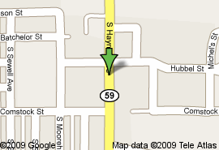

**General Information**

Standard cost for self-pay mammogram $250.00

Usual wait for a screening mammogram 1-2 days

Do patients need to provide a referral No

Type of mammography machines Digital

Radiologist On-site No

Contract Radiologist Automatically sent to Billings

**Facility Access Information**

**Van Accessible Parking Yes**

**Standard Accessible Parking Yes**

**Accessible Exterior Route Yes**

Accessible path Yes

Accessible doors Yes

**Accessible Interior Route Yes**

**Accessible Mammography Room Yes**

Accessible doors Yes

Accessible route and maneuvering space Yes

Lowest height of x-ray plate from floor 24 inches

**Accessible Restroom on Same Floor Yes**

Accessible route and turning space Yes

Accessible toilet, fixtures and sink Yes

**Language/Alternative Communication**

**Spoken:** English, Spanish, Other

**Printed:** English

**Video**: None

**Braille:** English

**Large Print:** No

**Sign Language:** No

**Additional Service**

* Accepts Medicaid Patients
* Accepts Medicare Patients
* Free Screening Mammograms
* Diagnostic Mammograms
* Ultrasound/Sonogram
* Complimentary Therapies
* Referral Services
* Breast Self-Exam Training
* Chemotherapy
* Physical Therapy
* Dietician
* Located on a bus route

**Note**: The available information was gathered spring 2015. Some features including costs, may have changed. Please call the facility for current information.

When scheduling an appointment, notify the facility if you require accommodations.

Keys to symbols: ✝ Radiologist and/or Computer Assisted Device charges not included



**Billings Clinic Center for**

**Breast Health**

**406-238-2501**

801 29th Street

Billings, MT 59107

**Hours: 7:00AM-5:30PM; M-F**

[www.billingsclinic.com](http://www.billingsclinic.com)

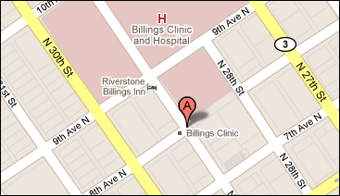

**General Information**

Standard cost for self-pay mammogram $278.00

Usual wait for a screening mammogram 1 day

Do patients need to provide a referral No

Type of mammography machines Digital

Radiologist On-site Yes

Type of mammography machines Digital (2)

3D (1)

**Facility Access Information**

**Van Accessible Parking Yes**

**Standard Accessible Parking Yes**

**Accessible Exterior Route Yes**

Accessible path Yes

Accessible doors Yes

**Accessible Interior Route Yes**

**Accessible Mammography Room Yes**

Accessible doors Yes

Accessible route and maneuvering space Yes

Lowest height of x-ray plate from floor 18 inches

**Accessible Restroom on Same Floor Yes**

Accessible route and turning space Yes

Accessible toilet, fixtures and sink Yes

**Language/Alternative Communication**

**Spoken:** English, Spanish, Other

**Printed:** English, Spanish

**Video**: None

**Braille:** No

**Large Print:** No

**Sign Language:** Yes

**Additional Service**

* Accepts Medicaid Patients
* Accepts Medicare Patients
* Free Screening Mammograms
* Diagnostic Mammograms
* Ultrasound/Sonogram
* CT/MRI/PET Scan
* Stereotactic Biopsy
* Needle Localization
* Galactograms
* Referral Services
* Breast Self-Exam Training
* Information on the Internet
* RN Certified in Breast Cancer
* Patient Navigator
* Chemotherapy
* Physical Therapy
* Radiation Therapy
* Clinical Trials
* Tumor Board
* Tumor Registry
* Located on a bus route
* Cancer Group/Breast Cancer Group
* Family Cancer Group
* Grief and Bereavement/Spiritual
* Scarves/Turbans

**Note**: The available information was gathered spring 2015. Some features including costs, may have changed. Please call the facility for current information.

When scheduling an appointment, notify the facility if you require accommodations.

Keys to symbols: ✝ Radiologist and/or Computer Assisted Device charges not included



**Billings Clinic West**

**406-238-2501** ✝✝✝

2675 Central Avenue

Billings, MT 59102

**Hours: 7:30AM-6:00PM**

**Mammogram Hours: 8:00AM-4:30PM**

[www.billingsclinic.com](http://www.billingsclinic.com)

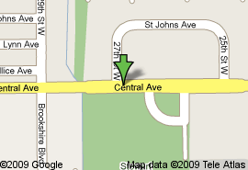

**General Information**

Standard cost for self-pay mammogram $252.00

Usual wait for a screening mammogram 3-4 days

Do patients need to provide a referral Yes

Type of mammography machines Digital

Radiologist On-site No

Contract Radiologist Yes

**Facility Access Information**

**Van Accessible Parking Yes**

**Standard Accessible Parking Yes**

**Accessible Exterior Route Yes**

Accessible path Yes

Accessible doors Yes

**Accessible Interior Route Yes**

**Accessible Mammography Room Yes**

Accessible doors Yes

Accessible route and maneuvering space Yes

Lowest height of x-ray plate from floor 25 inches

**Accessible Restroom on Same Floor Yes**

Accessible route and turning space Yes

Accessible toilet, fixtures and sink Yes

**Language/Alternative Communication**

**Spoken:** English

**Printed:** None

**Video**: None

**Braille:** English

**Large Print:** No

**Sign Language:** No

**Additional Service**

* Accepts Medicaid Patients
* Accepts Medicare Patients
* Shower Cards
* Located on a bus route

**Note**: The available information was gathered spring 2015. Some features including costs, may have changed. Please call the facility for current information.

When scheduling an appointment, notify the facility if you require accommodations.

Keys to symbols: ✝ Radiologist and/or Computer Assisted Device charges not included. ✝✝✝ Main appointment desk for scheduling; ask to be scheduled at the West End Facility.



**Blackfeet Community Hospital**

**406-338-6177**

760 New Hospital Circle

Browning, MT 59417

**Hours: 8:30AM-4:00PM; Tues and Wed**

The Winkley Women’s Center is a mobile coach that provides mammography, breast ultrasound and bone density testing in 10 Montana communities including Browning, Chester, Choteau, Conrad, Cut Bank, Eureka, Fort Benton, Kalispell, Polson, Malta, and Plains.

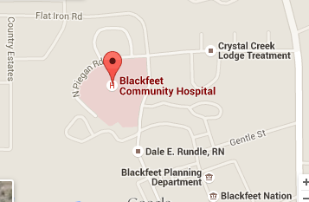

**General Information**

Standard cost for self-pay mammogram Free**\***

***\*Eligible tribal members only***

Usual wait for a screening mammogram 2 weeks

Do patients need to provide a referral Yes

Type of mammography machines Digital

Radiologist On-site No

Contract Radiologist Yes

**Facility Access Information**

**Van Accessible Parking Unknown**

**Standard Accessible Parking Unknown**

**Accessible Exterior Route Unknown**

Accessible path Unknown

Accessible doors Unknown

**Accessible Interior Route Yes**

**Accessible Mammography Room Yes**

Accessible doors Yes

Accessible route and maneuvering space Yes

Lowest height of x-ray plate from floor 27 inches

**Accessible Restroom on Same Floor No**

Accessible route and turning space Unknown

Accessible toilet, fixtures and sink Unknown

**Language/Alternative Communication**

**Spoken:** English

**Printed:** English

**Video**: None

**Braille:** No

**Large Print:** English

**Sign Language:** No

**Additional Service**

* Accepts Medicaid Patients
* Accepts Medicare Patients
* Free/Reduced Rate Screening Mammograms
* Second Opinion
* Breast Self-Exam Training
* Patient Information/Education
* Breast Cancer Patient Navigator
* Diagnostic Mammograms
* Ultrasound/Sonogram
* DXA

**Note**: The available information was gathered spring 2015. Some features including costs, may have changed. Please call the facility for current information.

When scheduling an appointment, notify the facility if you require accommodations.

Keys to symbols: ✝ Radiologist and/or Computer Assisted Device charges not included.



**Broadwater Health Center**

**406-751-9729**

110 North Oak Street

Townsend, MT 59644

**Hours: Varies; Usually 8:30AM-4:30PM**

[www.broadwaterhealthcenter.com](http://www.broadwaterhealthcenter.com)

The Winkley Women’s Center is a mobile coach that provides mammography, breast ultrasound and bone density testing in 10 Montana communities including Browning, Chester, Choteau, Conrad, Cut Bank, Eureka, Fort Benton, Kalispell, Polson, Malta, and Plains.

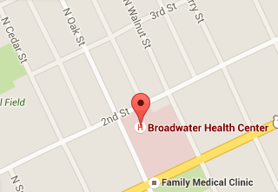

**General Information**

Standard cost for self-pay mammogram Site Specific

***\*Call site for pricing***

Usual wait for a screening mammogram 2 weeks

Do patients need to provide a referral Yes

Type of mammography machines Digital

Radiologist On-site No

Contract Radiologist Yes

**Facility Access Information**

**Van Accessible Parking Unknown**

**Standard Accessible Parking Unknown**

**Accessible Exterior Route Unknown**

Accessible path Unknown

Accessible doors Unknown

**Accessible Interior Route Yes**

**Accessible Mammography Room Yes**

Accessible doors Yes

Accessible route and maneuvering space Yes

Lowest height of x-ray plate from floor 27 inches

**Accessible Restroom on Same Floor Unknown**

Accessible route and turning space Unknown

Accessible toilet, fixtures and sink Unknown

**Language/Alternative Communication**

**Spoken:** English

**Printed:** English

**Video**: None

**Braille:** No

**Large Print:** No

**Sign Language:** No

**Additional Service**

* Diagnostic Mammograms
* Ultrasound/Sonogram
* DXA

**Note**: The available information was gathered spring 2015. Some features including costs, may have changed. Please call the facility for current information.

When scheduling an appointment, notify the facility if you require accommodations.

Keys to symbols: ✝ Radiologist and/or Computer Assisted Device charges not included.



**Cabinet Peaks Medical Center**

**406-293-0149**

350 Louisiana Street

Libby, MT 59923

**Hours: 9:00AM-4:00PM; M-F**

[www.cabinetpeaks.org](http://www.cabinetpeaks.org)

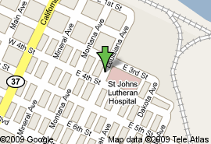

**General Information**

Standard cost for self-pay mammogram $230.00 ✝

Usual wait for a screening mammogram 1-2 days

Do patients need to provide a referral Yes

Type of mammography machines Digital

Radiologist On-site Yes

Type of mammography machines Digital

**Facility Access Information**

**Van Accessible Parking Yes**

**Standard Accessible Parking Yes**

**Accessible Exterior Route Yes**

Accessible path Yes

Accessible doors Yes

**Accessible Interior Route Yes**

**Accessible Mammography Room No**

Accessible doors No

Accessible route and maneuvering space Yes

Lowest height of x-ray plate from floor 27 inches

**Accessible Restroom on Same Floor No**

Accessible route and turning space Yes

Accessible toilet, fixtures and sink No

**Language/Alternative Communication**

**Spoken:** English, Spanish

**Printed:** English

**Video**: None

**Braille:** English

**Large Print:** No

**Sign Language:** Yes

**Additional Service**

* Accepts Medicaid Patients
* Accepts Medicare Patients
* Reduced Rate Screening Mammograms
* Diagnostic Mammograms
* Ultrasound/Sonogram
* CT/MRI/PET Scan
* Stereotactic Biopsy
* Incisional Biopsy
* Referral Services
* Breast Self-Exam Training
* Information on the Internet
* Home Care/Hospice
* Chemotherapy
* Physical Therapy
* Radiation Therapy
* Tumor Board
* Tumor Registry
* Located on a bus route
* Transportation Services
* Cancer Group
* Breast Prosthetics/Reconstruction
* Wigs/Hair Pieces
* Scarves/Turbans

**Note**: The available information was gathered spring 2015. Some features including costs, may have changed. Please call the facility for current information.

When scheduling an appointment, notify the facility if you require accommodations.

Keys to symbols: ✝ Radiologist and/or Computer Assisted Device charges not included



**Central Montana Medical Center**

**406-535-6205**

408 Wendell

Lewistown, MT 59457

**Hours: 8:00AM-5:00PM; Mon-Fri**

[www.cmmccares.com](http://www.cmmccares.com)

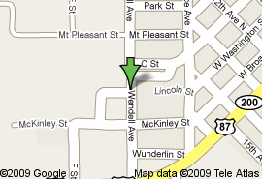

**General Information**

Standard cost for self-pay mammogram $226.75

Usual wait for a screening mammogram 1-2 days

Do patients need to provide a referral No

Type of mammography machines Digital

Radiologist On-site Full-time

**Facility Access Information**

**Van Accessible Parking Yes**

**Standard Accessible Parking Yes**

**Accessible Exterior Route Yes**

Accessible path Yes

Accessible doors Yes

**Accessible Interior Route Yes**

**Accessible Mammography Room Yes**

Accessible doors Yes

Accessible route and maneuvering space Yes

Lowest height of x-ray plate from floor 11 inches

**Accessible Restroom on Same Floor Yes**

Accessible route and turning space Yes

Accessible toilet, fixtures and sink Yes

**Language/Alternative Communication**

**Spoken:** English, Spanish

**Printed:** English

**Video**: English

**Braille:** No

**Large Print:** English

**Sign Language:** Yes

**Additional Service**

* Free Screening Mammograms
* Accepts Medicaid Patients
* Accepts Medicare Patients
* Diagnostic Mammograms
* Ultrasound/Sonogram
* Needle Localizations
* Chemotherapy
* Physical Therapy
* Tumor Registry
* Home Care/Hospice
* Referral Services
* Second Opinion

**Note**: The available information was gathered spring 2015. Some features including costs, may have changed. Please call the facility for current information.

When scheduling an appointment, notify the facility if you require accommodations.

Keys to symbols: ✝ Radiologist and/or Computer Assisted Device charges not included.



**Clark Fork Valley Hospital**

**406-826-4980**

110 Kruger Road

Plains, MT 59859

**Hours: 8:00AM-6:00PM; Tues-Fri**

[www.cfvh.org](http://www.cfvh.org)

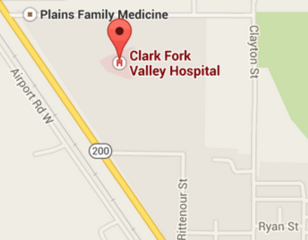

**General Information**

Standard cost for self-pay mammogram $203.00

Usual wait for a screening mammogram 0-2 days

Do patients need to provide a referral Yes

Type of mammography machines Digital

Radiologist On-site No

Contract Radiologist Yes

**Facility Access Information**

**Van Accessible Parking No**

**Standard Accessible Parking No**

**Accessible Exterior Route Yes**

Accessible path Yes

Accessible doors No

**Accessible Interior Route Yes**

**Accessible Mammography Room Yes**

Accessible doors Yes

Accessible route and maneuvering space Yes

Lowest height of x-ray plate from floor 27 inches

**Accessible Restroom on Same Floor** **Yes**

Accessible route and turning space Yes

Accessible toilet, fixtures and sink Yes

**Language/Alternative Communication**

**Spoken:** English, Spanish

**Printed:** English

**Video**: None

**Braille:** No

**Large Print:** No

**Sign Language:** No

**Additional Service**

* Free/Reduced Rate Screening Mammograms
* Accepts Medicaid Patients
* Accepts Medicare Patients
* Diagnostic Mammograms
* Home Care
* Shuttle Services

**Note**: The available information was gathered spring 2015. Some features including costs, may have changed. Please call the facility for current information.

When scheduling an appointment, notify the facility if you require accommodations.

Keys to symbols: ✝ Radiologist and/or Computer Assisted Device charges not included.



**Crow-Northern Cheyenne Hospital**

**406-638-2626**

South 7650 East, 1010,

Crow Agency, MT 59022

**Hours: Varies**

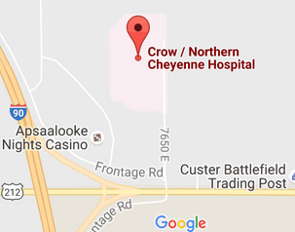

**General Information**

Standard cost for self-pay mammogram $203.00

Usual wait for a screening mammogram 0-2 days

Do patients need to provide a referral Yes

Type of mammography machines Digital

Radiologist On-site No

Contract Radiologist Yes

**Facility Access Information**

**Disability access information: *The St. Vincent Mobile Coach does not have an accessible entrance; however, Rosebud Health Care provides entrance, standard parking, and restroom access.***

**Van Accessible Parking No**

**Standard Accessible Parking No**

**Accessible Exterior Route Yes**

Accessible path Yes

Accessible doors Yes

**Accessible Interior Route Yes**

**Accessible Mammography Room Yes**

Accessible doors Yes

Accessible route and maneuvering space Yes

Lowest height of x-ray plate from floor 27 inches

**Accessible Restroom on Same Floor** **Yes**

Accessible route and turning space Yes

Accessible toilet, fixtures and sink Yes

**Language/Alternative Communication**

**Spoken:** English, Spanish

**Printed:** English

**Video**: None

**Braille:** No

**Large Print:** No

**Sign Language:** No

**Additional Service**

* Free/Reduced Rate Screening Mammograms
* Accepts Medicaid Patients
* Accepts Medicare Patients
* Diagnostic Mammograms
* Home Care
* Shuttle Services

**Note**: The available information was gathered spring 2015. Some features including costs, may have changed. Please call the facility for current information.

When scheduling an appointment, notify the facility if you require accommodations.

Keys to symbols: ✝ Radiologist and/or Computer Assisted Device charges not included.



**Deer Lodge Medical Center**

**406-846-7701**

1100 Hollenback Lane

Deer Lodge, MT 59722

**Hours: 8:00AM-5:00PM; Mon-Fri**

[www.dlmed.org](http://www.dlmed.org)

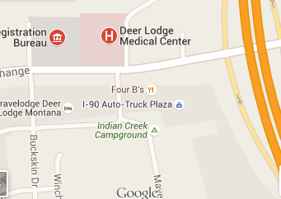

**General Information**

Standard cost for self-pay mammogram $250.95

Usual wait for a screening mammogram Same day

Do patients need to provide a referral No

Type of mammography machines Digital

Radiologist On-site Part-time

Contract Radiologist No

**Facility Access Information**

**Van Accessible Parking Unknown**

**Standard Accessible Parking Unknown**

**Accessible Exterior Route Unknown**

Accessible path Unknown

Accessible doors Unknown

**Accessible Interior Route Unknown**

**Accessible Mammography Room Unknown**

Accessible doors Unknown

Accessible route and maneuvering space Unknown

Lowest height of x-ray plate from floor 21 inches

**Accessible Restroom on Same Floor Unknown**

Accessible route and turning space Unknown

Accessible toilet, fixtures and sink Unknown

**Language/Alternative Communication**

**Spoken:** English, Spanish

**Printed:** English

**Video**: English

**Braille:** No

**Large Print:** No

**Sign Language:** No

**Additional Service**

* Accepts Medicaid Patients
* Accepts Medicare Patients
* Information on Internet
* Patient Information/Education
* Reduced Rate Screening Mammograms
* Counseling
* Diagnostic Mammograms
* CT/MRI
* Ultrasound/Sonogram
* Home Care/Hospice
* Complementary Therapies
* Nutrition
* Referral Services
* Second Opinion
* Physical Therapy
* Family/Caregiver
* Grief and Bereavement
* Spiritual
* Located on a bus route
* Offers Transportation Services

**Note**: The available information was gathered spring 2015. Some features including costs, may have changed. Please call the facility for current information.

When scheduling an appointment, notify the facility if you require accommodations.

Keys to symbols: ✝ Radiologist and/or Computer Assisted Device charges not included.



**Eureka Health Prompt Care**

**406-297-3145**

298 Osloski Road

Eureka, MT 59917

**Hours: 8:30AM-4:00PM; W, F**

**Bi-monthly**

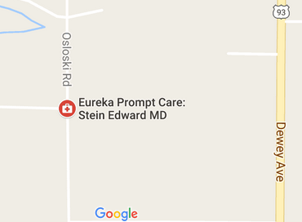

**General Information**

Standard cost for self-pay mammogram $221.50

Usual wait for a screening mammogram 1 week

Do patients need to provide a referral Yes

Type of mammography machines Digital

Radiologist On-site No

Contract Radiologist Yes

**Facility Access Information**

**Van Accessible Parking Unknown**

**Standard Accessible Parking Unknown**

**Accessible Exterior Route Unknown**

Accessible path Unknown

Accessible doors Unknown

**Accessible Interior Route Yes**

**Accessible Mammography Room Yes**

Accessible doors Yes

Accessible route and maneuvering space Yes

Lowest height of x-ray plate from floor 27 inches

**Accessible Restroom on Same Floor Unknown**

Accessible route and turning space Unknown

Accessible toilet, fixtures and sink Unknown

**Language/Alternative Communication**

**Spoken:** English

**Printed:** English

**Video**: None

**Braille:** No

**Large Print:** No

**Sign Language:** No

**Additional Service**

* Diagnostic Mammograms
* CT
* Biopsy
* Ultrasound/Sonogram

**Note**: The available information was gathered spring 2015. Some features including costs, may have changed. Please call the facility for current information.

When scheduling an appointment, notify the facility if you require accommodations.

Keys to symbols: ✝ Radiologist and/or Computer Assisted Device charges not included.



**Fallon Medical Complex**

**406-778-5147**

202 South 4th Street West

Baker, MT 59313

**Hours: 8:00AM-5:00PM**

[www.fallonmedical.org](http://www.fallonmedical.org)

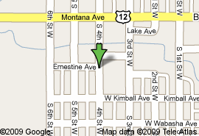

**General Information**

Standard cost for self-pay mammogram $241.00

Usual wait for a screening mammogram ½-1 day

Do patients need to provide a referral No

Type of mammography machines Digital

Radiologist On-site Not on-site/ Accessible via Teleradiology

**Facility Access Information**

**Van Accessible Parking Yes**

**Standard Accessible Parking Yes**

**Accessible Exterior Route Yes**

Accessible path Yes

Accessible doors Yes

**Accessible Interior Route Yes**

**Accessible Mammography Room Yes**

Accessible doors Yes

Accessible route and maneuvering space Yes

Lowest height of x-ray plate from floor 23 inches

**Accessible Restroom on Same Floor Yes**

Accessible route and turning space Yes

Accessible toilet, fixtures and sink Yes

**Language/Alternative Communication**

**Spoken:** English, Spanish, Russian

**Printed:** None

**Video**: English

**Braille:** No

**Large Print:** English

**Sign Language:** Yes

**Additional Service**

* Reduced Rate Screening Mammograms
* Offers Free Screening Mammograms
* Accepts Medicaid Patients
* Accepts Medicare Patients
* Breast Prosthetics
* Breast Reconstruction
* Physical Therapy
* Breast Cancer Survivor Group
* Breast Health Coordinator
* Home Care
* Nutrition
* Referral Services
* Located on a bus route
* Local bus will pick up patients

**Note**: The available information was gathered spring 2015. Some features including costs, may have changed. Please call the facility for current information.

When scheduling an appointment, notify the facility if you require accommodations.

Keys to symbols: ✝ Radiologist and/or Computer Assisted Device charges not included.



**Frances Mahon Deaconess Hospital**

**406-228-3630**

621 3rd Street South

Glasgow, MT 59230

**Hours: 8:00AM-5:00PM**

[www.fmdh.org](http://www.fmdh.org)

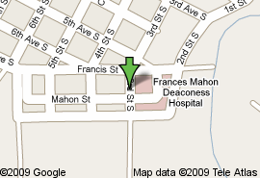

**General Information**

Standard cost for self-pay mammogram $171.00

Usual wait for a screening mammogram 1-2 weeks

Do patients need to provide a referral Yes

Type of mammography machines Digital

Radiologist On-site Full-time

**Facility Access Information**

**Van Accessible Parking Yes**

**Standard Accessible Parking Yes**

**Accessible Exterior Route Yes**

Accessible path Yes

Accessible doors Yes

**Accessible Interior Route Yes**

**Accessible Mammography Room Yes**

Accessible doors Yes

Accessible route and maneuvering space Yes

Lowest height of x-ray plate from floor 24 inches

**Accessible Restroom on Same Floor Yes**

Accessible route and turning space Yes

Accessible toilet, fixtures and sink Yes

**Language/Alternative Communication**

**Spoken:** English

**Printed:** English

**Video**: None

**Braille:** No

**Large Print:** No

**Sign Language:** No

**Additional Service**

* Free Screening Mammograms
* Accepts Medicaid Patients
* Accepts Medicare Patients
* Physical Therapy
* Chemotherapy
* Breast Self-Exam Training
* Diagnostic Mammograms
* CT/MRI
* Ultrasound/Sonogram
* Referral Services
* Located on a bus route

**Note**: The available information was gathered spring 2015. Some features including costs, may have changed. Please call the facility for current information.

When scheduling an appointment, notify the facility if you require accommodations.

Keys to symbols: ✝ Radiologist and/or Computer Assisted Device charges not included.



**Fort Belknap Center IHS**

**406-353-3142**

669 Agency Main Street

Harlem, MT 59526

**Hours: 8:00AM-5:00PM**

[www.ihs.gov/billings/healthcarefacilities/ftbelknap/](http://www.ihs.gov/billings/healthcarefacilities/ftbelknap/)

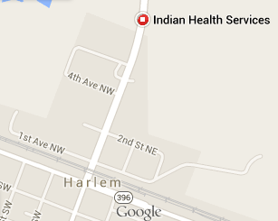

**General Information**

Standard cost for self-pay mammogram IHS covers

Usual wait for a screening mammogram 3 days

Do patients need to provide a referral No

Type of mammography machines Digital

Radiologist On-site No

Contract Radiologist Yes

**Facility Access Information**

**Van Accessible Parking No**

**Standard Accessible Parking No**

**Accessible Exterior Route Yes**

Accessible path Yes

Accessible doors Yes

**Accessible Interior Route Yes**

**Accessible Mammography Room Yes**

Accessible doors Yes

Accessible route and maneuvering space Yes

Lowest height of x-ray plate from floor 25 inches

**Accessible Restroom on Same Floor No**

Accessible route and turning space Yes

Accessible toilet, fixtures and sink Yes

**Language/Alternative Communication**

**Spoken:** English

**Printed:** None

**Video**: None

**Braille:** No

**Large Print:** No

**Sign Language:** No

**Additional Service**

* Free Screening Mammograms
* Reduced Rate Screening Mammograms (IHS)
* Accepts Medicaid Patients
* Accepts Medicare Patients
* Education and Information
* Breast Cancer Group
* Spiritual
* Home Care
* Transportation Services

**Note**: The available information was gathered spring 2015. Some features including costs, may have changed. Please call the facility for current information.

When scheduling an appointment, notify the facility if you require accommodations.

Keys to symbols: ✝ Radiologist and/or Computer Assisted Device charges not included.



**Glendive Medical Center**

**406-345-3330**

202 Prospect Drive

Glendive, MT 59330

**Hours: 8:00AM-5:00PM**

[www.gmc.org](http://www.gmc.org)

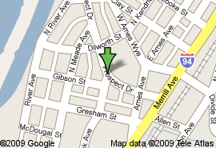

**General Information**

Standard cost for self-pay mammogram $286.30 ✝

Usual wait for a screening mammogram 2 days

Do patients need to provide a referral No

Type of mammography machines Digital

Radiologist On-site Full-time

Contract Radiologist No

**Facility Access Information**

**Van Accessible Parking Yes**

**Standard Accessible Parking Yes**

**Accessible Exterior Route Yes**

Accessible path Yes

Accessible doors Yes

**Accessible Interior Route Yes**

**Accessible Mammography Room Yes**

Accessible doors Yes

Accessible route and maneuvering space Yes

Lowest height of x-ray plate from floor 24 inches

**Accessible Restroom on Same Floor Yes**

Accessible route and turning space Yes

Accessible toilet, fixtures and sink Yes

**Language/Alternative Communication**

**Spoken:** English

**Printed:** None

**Video**: None

**Braille:** No

**Large Print:** No

**Sign Language:** No

**Additional Service**

* Reduced Rate Screening Mammograms
* Accepts Medicaid Patients
* Accepts Medicare Patients
* Breast Self-Exam Training
* Breast Cancer Group
* Family Cancer Group
* Grief and Bereavement
* Located on a bus route

**Note**: The available information was gathered spring 2015. Some features including costs, may have changed. Please call the facility for current information.

When scheduling an appointment, notify the facility if you require accommodations.

Keys to symbols: ✝ Radiologist and/or Computer Assisted Device charges not included.



**Great Falls Clinic Medical Center**

**406-771-3159**

3000 15th Avenue South

Great Falls, MT 59405

**Hours: 8:00AM-4:30PM**

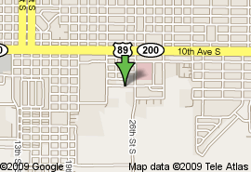

**General Information**

Standard cost for self-pay mammogram $

Usual wait for a screening mammogram Same day

Do patients need to provide a referral Yes

Type of mammography machines Digital

Radiologist On-site Full-time

Contract Radiologist No

**Facility Access Information**

**Van Accessible Parking Yes**

**Standard Accessible Parking Yes**

**Accessible Exterior Route Yes**

Accessible path Yes

Accessible doors Yes

**Accessible Interior Route Yes**

**Accessible Mammography Room Yes**

Accessible doors Unknown

Accessible route and maneuvering space Unknown

Lowest height of x-ray plate from floor 24 inches

**Accessible Restroom on Same Floor Yes**

Accessible route and turning space Yes

Accessible toilet, fixtures and sink Yes

**Language/Alternative Communication**

**Spoken:** English

**Printed:** English

**Video**: None

**Braille:** No

**Large Print:** No

**Sign Language:** Yes

**Additional Service**

* Reduced Rate Screening Mammograms
* Accepts Medicaid Patients
* Accepts Medicare Patients
* Diagnostic Mammograms
* Ultrasound/Sonogram
* Located on a bus route

**Note**: The available information was gathered spring 2015. Some features including costs, may have changed. Please call the facility for current information.

When scheduling an appointment, notify the facility if you require accommodations.

Keys to symbols: ✝ Radiologist and/or Computer Assisted Device charges not included.



**Helena Imaging Center**

**406-442-7227**

25 Medical Park Drive

Helena, MT 59601

**Hours: 8:30AM-4:30PM; M-F**

[www.helenaimaging.com](http://www.helenaimaging.com)

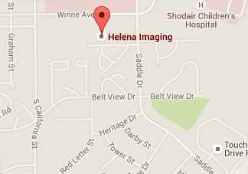

**General Information**

Standard cost for self-pay mammogram $275.91

Usual wait for a screening mammogram Same day

Do patients need to provide a referral No but preferred

Type of mammography machines Digital

Radiologist On-site Part-time

Contract Radiologist No

**Facility Access Information**

**Van Accessible Parking Unknown**

**Standard Accessible Parking Unknown**

**Accessible Exterior Route Unknown**

Accessible path Unknown

Accessible doors Unknown

**Accessible Interior Route Unknown**

**Accessible Mammography Room Unknown**

Accessible doors Unknown

Accessible route and maneuvering space Unknown

Lowest height of x-ray plate from floor 21 inches

**Accessible Restroom on Same Floor Unknown**

Accessible route and turning space Unknown

Accessible toilet, fixtures and sink Unknown

**Language/Alternative Communication**

**Spoken:** English, Spanish

**Printed:** English

**Video**: None

**Braille:** No

**Large Print:** No

**Sign Language:** No

**Additional Service**

* Free/Reduced Rate Screening Mammograms
* Accepts Medicaid Patients
* Accepts Medicare Patients
* Counseling
* Diagnostic Mammograms
* CT
* Biopsy
* Ultrasound/Sonogram
* Information/Education
* Located on a Bus Route
* Offers Transportation Services

**Note**: The available information was gathered spring 2015. Some features including costs, may have changed. Please call the facility for current information.

When scheduling an appointment, notify the facility if you require accommodations.

Keys to symbols: ✝ Radiologist and/or Computer Assisted Device charges not included.



**Holy Rosary Healthcare**

**406-233-2600**

2600 Wilson Street

Miles City, MT 59301

**Hours: 8:30AM-5:00PM**

[www.holyrosaryhealthcare.org](http://www.holyrosaryhealthcare.org)

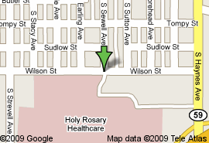

**General Information**

Standard cost for self-pay mammogram $250.00

Usual wait for a screening mammogram 1-2 days

Do patients need to provide a referral No

Type of mammography machines Digital; 3D

Radiologist On-site Full-time

Contract Radiologist No

**Facility Access Information**

**Van Accessible Parking Yes**

**Standard Accessible Parking Yes**

**Accessible Exterior Route Yes**

Accessible path Yes

Accessible doors Yes

**Accessible Interior Route Yes**

**Accessible Mammography Room Yes**

Accessible doors Yes

Accessible route and maneuvering space Yes

Lowest height of x-ray plate from floor 22 inches

**Accessible Restroom on Same Floor Yes**

Accessible route and turning space Yes

Accessible toilet, fixtures and sink Yes

**Language/Alternative Communication**

**Spoken:** English

**Printed:** English

**Video**: None

**Braille:** No

**Large Print:** No

**Sign Language:** No

**Additional Service**

* Accepts Medicaid Patients
* Accepts Medicare Patients
* Diagnostic Mammograms
* Ultrasound/Sonogram
* Positron Emission Tomography (PET) Scan
* Breast Self-Exam Training
* Chemotherapy
* Physical Therapy
* Home Care/Hospice
* Referral Services
* Second Opinion
* Grief and Bereavement
* Located on a bus route

**Note**: The available information was gathered spring 2015. Some features including costs, may have changed. Please call the facility for current information.

When scheduling an appointment, notify the facility if you require accommodations.

Keys to symbols: ✝ Radiologist and/or Computer Assisted Device charges not included.



**Liberty Medical Center**

**406-759-5181**

418 West Monroe Avenue

Chester, MT 59522

**Hours: 8:30AM-4:00PM; Tues,**

**Bi-monthly**

[www.libertymedicalcenter.org](http://www.libertymedicalcenter.org)

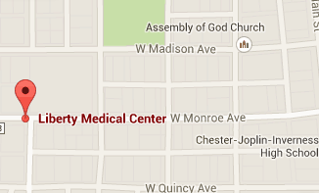

**General Information**

Standard cost for self-pay mammogram $183.50

Usual wait for a screening mammogram Varies

Do patients need to provide a referral Yes

Type of mammography machines Digital

Radiologist On-site No

Contract Radiologist Yes

**Facility Access Information**

**Van Accessible Parking No**

**Standard Accessible Parking No**

**Accessible Exterior Route Yes**

Accessible path Yes

Accessible doors Yes

**Accessible Interior Route Yes**

**Accessible Mammography Room Yes**

Accessible doors Yes

Accessible route and maneuvering space Yes

Lowest height of x-ray plate from floor 27 inches

**Accessible Restroom on Same Floor No**

Accessible route and turning space Yes

Accessible toilet, fixtures and sink No

**Language/Alternative Communication**

**Spoken:** English

**Printed:** English

**Video**: None

**Braille:** No

**Large Print:** No

**Sign Language:** No

**Additional Service**

* Accepts Medicaid Patients
* Accepts Medicare Patients
* Diagnostic Mammograms
* Ultrasound/Sonogram
* Patient Information/Education
* Located on a bus route

**Note**: The available information was gathered spring 2015. Some features including costs, may have changed. Please call the facility for current information.

When scheduling an appointment, notify the facility if you require accommodations.

Keys to symbols: ✝ Radiologist and/or Computer Assisted Device charges not included.



**Livingston HealthCare**

**406-823-6441**

504 South 13th

Livingston, MT 59704

**Hours: 8:00AM-4:00PM**

[www.livingstonhealthcare.org](http://www.livingstonhealthcare.org)

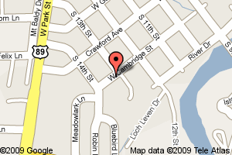

**General Information**

Standard cost for self-pay mammogram $362.00

(Discounts available)

Usual wait for a screening mammogram <1 week

Do patients need to provide a referral Yes

Type of mammography machines Digital

Radiologist On-site Full-time

Contract Radiologist No

**Facility Access Information**

**Van Accessible Parking No**

**Standard Accessible Parking No**

**Accessible Exterior Route No**

Accessible path No

Accessible doors No

**Accessible Interior Route Yes**

**Accessible Mammography Room No**

Accessible doors No

Accessible route and maneuvering space Yes

Lowest height of x-ray plate from floor 18 inches

**Accessible Restroom on Same Floor No**

Accessible route and turning space No

Accessible toilet, fixtures and sink Yes

**Language/Alternative Communication**

**Spoken:** English, Spanish, Other

**Printed:** English, Spanish

**Video**: None

**Braille:** No

**Large Print:** No

**Sign Language:** Yes

**Additional Service**

* Free Screening Mammograms
* Reduced Rate Screening Mammograms (through programs)
* Diagnostic Mammograms
* CT, MRI
* Ultrasound/Sonogram
* Needle Localization
* Breast Self-Exam Training
* Information on Internet
* Hospice/Home Care
* Chemotherapy
* Physical Therapy
* Tumor Board
* Referral Services
* Angle Line Transportation

**Note**: The available information was gathered spring 2015. Some features including costs, may have changed. Please call the facility for current information.

When scheduling an appointment, notify the facility if you require accommodations.

Keys to symbols: ✝ Radiologist and/or Computer Assisted Device charges not included.



**Marcus Daly Memorial Hospital**

**406-375-4426**

1200 Westwood Drive

Hamilton, MT 59840

**Hours: 8:00AM-5:00PM; M-F**

[www.mdmh.org](http://www.mdmh.org)

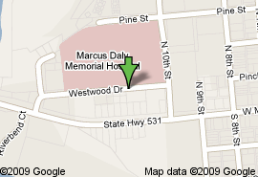

**General Information**

Standard cost for self-pay mammogram $236.20 ✝

Usual wait for a screening mammogram 10 days

Do patients need to provide a referral Yes

Type of mammography machines Digital

Radiologist On-site Full-time

Contract Radiologist No

**Facility Access Information**

**Van Accessible Parking Yes**

**Standard Accessible Parking Yes**

**Accessible Exterior Route Yes**

Accessible path Yes

Accessible doors Yes

**Accessible Interior Route Yes**

**Accessible Mammography Room Yes**

Accessible doors Yes

Accessible route and maneuvering space Yes

Lowest height of x-ray plate from floor 31 inches

**Accessible Restroom on Same Floor Yes**

Accessible route and turning space Yes

Accessible toilet, fixtures and sink Yes

**Language/Alternative Communication**

**Spoken:** English, Spanish, Russian

**Printed:** English, Spanish

**Video**: None

**Braille:** No

**Large Print:** No

**Sign Language:** Yes

**Additional Service**

* Accepts Medicaid Patients
* Accepts Medicare Patients
* Diagnostic Mammograms
* CT Scans
* Breast Self-Exam Training
* Breast Cancer Group
* Family Cancer Group
* Hospice/Home Care
* Chemotherapy
* Lymphedema Specialty Services
* Post-Operative Apparel
* Referral Services
* Bus Transportation can be arranged

**Note**: The available information was gathered spring 2015. Some features including costs, may have changed. Please call the facility for current information.

When scheduling an appointment, notify the facility if you require accommodations.

Keys to symbols: ✝ Radiologist and/or Computer Assisted Device charges not included.



**Marias Medical Center**

**406-434-3250**

640 Park Avenue

Shelby, MT 59474

**Hours: 8:00AM-4:00PM**

[www.mmcmt.org](http://www.mmcmt.org)

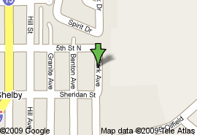

**General Information**

Standard cost for self-pay mammogram $100.00 ✝

Usual wait for a screening mammogram 1 day

Do patients need to provide a referral Yes

Type of mammography machines Digital

Radiologist On-site No

Contract Radiologist Yes

**Facility Access Information**

**Van Accessible Parking Yes**

**Standard Accessible Parking Yes**

**Accessible Exterior Route Yes**

Accessible path Yes

Accessible doors Yes

**Accessible Interior Route Yes**

**Accessible Mammography Room No**

Accessible doors No

Accessible route and maneuvering space Yes

Lowest height of x-ray plate from floor 29 inches

**Accessible Restroom on Same Floor No**

Accessible route and turning space Yes

Accessible toilet, fixtures and sink No

**Language/Alternative Communication**

**Spoken:** English

**Printed:** English

**Video**: None

**Braille:** No

**Large Print:** No

**Sign Language:** Yes

**Additional Service**

* Accepts Medicaid Patients
* Accepts Medicare Patients
* Diagnostic Mammograms
* Ultrasound/Sonogram
* Offer Nurse Home Transports
* Hospice
* Referral Services

**Note**: The available information was gathered spring 2015. Some features including costs, may have changed. Please call the facility for current information.

When scheduling an appointment, notify the facility if you require accommodations.

Keys to symbols: ✝ Radiologist and/or Computer Assisted Device charges not included.



**Mineral Community Hospital**

**406-822-3705**

1208 6th Avenue East

Superior, MT 59872

**Hours: 8:00AM-3:30PM; M-F**

[www.mineralcommunityhospital.com](http://www.mineralcommunityhospital.com)

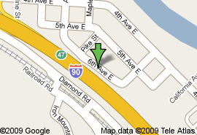

**General Information**

Standard cost for self-pay mammogram $205.00 ✝

Usual wait for a screening mammogram 1-2 days

Do patients need to provide a referral Yes

Type of mammography machines Digital

Radiologist On-site No

Contract Radiologist Yes

**Facility Access Information**

**Van Accessible Parking Yes**

**Standard Accessible Parking Yes**

**Accessible Exterior Route Yes**

Accessible path Yes

Accessible doors Yes

**Accessible Interior Route Yes**

**Accessible Mammography Room Yes**

Accessible doors Yes

Accessible route and maneuvering space Yes

Lowest height of x-ray plate from floor 11 inches

**Accessible Restroom on Same Floor Yes**

Accessible route and turning space Yes

Accessible toilet, fixtures and sink Yes

**Language/Alternative Communication**

**Spoken:** English, Spanish, Other

**Printed:** English

**Video**: None

**Braille:** No

**Large Print:** English

**Sign Language:** No

**Additional Service**

* Accepts Medicaid Patients
* Accepts Medicare Patients
* Reduced Rate Screening Mammogram
* CT, MRI
* Ultrasound/Sonogram
* Breast Self-Exam Training
* Information on Internet
* Offers type of transportation
* Referral Services

**Note**: The available information was gathered spring 2015. Some features including costs, may have changed. Please call the facility for current information.

When scheduling an appointment, notify the facility if you require accommodations.

Keys to symbols: ✝ Radiologist and/or Computer Assisted Device charges not included.



**Missouri River Medical Center**

**406-622-3331**

***See Facilities Below***

1501 St. Charles Street

Fort Benton, MT 59442

**Hours: Varies – Usually 8:30AM-4:30PM**

[www.mrmcfb.org](http://www.mrmcfb.org)

The Winkley Women’s Center is a mobile coach that provides mammography, breast ultrasound and bone density testing in 10 Montana communities including Browning, Chester, Choteau, Conrad, Cut Bank, Eureka, Fort Benton, Kalispell, Polson, Malta, and Plains.

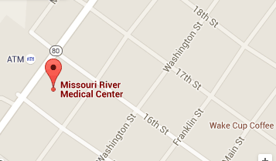

**General Information**

Standard cost for self-pay mammogram Site Specific

Usual wait for a screening mammogram 2 weeks

Do patients need to provide a referral Yes

Type of mammography machines Digital

Radiologist On-site No

Contract Radiologist Yes

**Facility Access Information**

**Van Accessible Parking Unknown**

**Standard Accessible Parking Unknown**

**Accessible Exterior Route Unknown**

Accessible path Unknown

Accessible doors Unknown

**Accessible Interior Route Yes**

**Accessible Mammography Room Yes**

Accessible doors Yes

Accessible route and maneuvering space Yes

Lowest height of x-ray plate from floor 27 inches

**Accessible Restroom on Same Floor No**

Accessible route and turning space Unknown

Accessible toilet, fixtures and sink Unknown

**Language/Alternative Communication**

**Spoken:** English

**Printed:** English

**Video**: None

**Braille:** No

**Large Print:** No

**Sign Language:** No

**Additional Service**

* Diagnostic Mammograms
* Ultrasound/Sonogram
* DXA

**Note**: The available information was gathered spring 2015. Some features including costs, may have changed. Please call the facility for current information.

When scheduling an appointment, notify the facility if you require accommodations.

Keys to symbols: ✝ Radiologist and/or Computer Assisted Device charges not included.



**Northern Rockies Medical Center**

**406-873-3700**

802 2nd Street Southeast

Cut Bank, MT 59427

**Hours: Varies – Usually 8:30AM-4:30PM**

[www.nrmcinc.org](http://www.nrmcinc.org)

The Winkley Women’s Center is a mobile coach that provides mammography, breast ultrasound and bone density testing in 10 Montana communities including Browning, Chester, Choteau, Conrad, Cut Bank, Eureka, Fort Benton, Kalispell, Polson, Malta, and Plains.

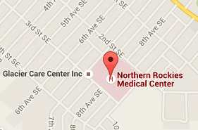

**General Information**

Standard cost for self-pay mammogram Site Specific

Usual wait for a screening mammogram 2 weeks

Do patients need to provide a referral Yes

Type of mammography machines Digital

Radiologist On-site No

Contract Radiologist Yes

**Facility Access Information**

**Van Accessible Parking Unknown**

**Standard Accessible Parking Unknown**

**Accessible Exterior Route Unknown**

Accessible path Unknown

Accessible doors Unknown

**Accessible Interior Route Yes**

**Accessible Mammography Room Yes**

Accessible doors Yes

Accessible route and maneuvering space Yes

Lowest height of x-ray plate from floor 27 inches

**Accessible Restroom on Same Floor No**

Accessible route and turning space Unknown

Accessible toilet, fixtures and sink Unknown

**Language/Alternative Communication**

**Spoken:** English

**Printed:** English

**Video**: None

**Braille:** No

**Large Print:** No

**Sign Language:** No

**Additional Service**

* Diagnostic Mammograms
* Ultrasound/Sonogram
* DXA

**Note**: The available information was gathered spring 2015. Some features including costs, may have changed. Please call the facility for current information.

When scheduling an appointment, notify the facility if you require accommodations.

Keys to symbols: ✝ Radiologist and/or Computer Assisted Device charges not included.



**North Valley Hospital**

**406-863-3576 or 877-399-0384**

1600 Hospital Way

Whitefish, MT 59937

**Hours: 8:00AM-4:00PM**

www.nvhosp.org

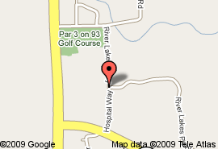

**General Information**

Standard cost for self-pay mammogram $120.00 ✝

Usual wait for a screening mammogram 1 week

Do patients need to provide a referral Yes

Type of mammography machines Digital

Radiologist On-site Full-time

**Facility Access Information**

**Van Accessible Parking Yes**

**Standard Accessible Parking Yes**

**Accessible Exterior Route No**

Accessible path No

Accessible doors Yes

**Accessible Interior Route Yes**

**Accessible Mammography Room Yes**

Accessible doors Yes

Accessible route and maneuvering space Yes

Lowest height of x-ray plate from floor 26 inches

**Accessible Restroom on Same Floor No**

Accessible route and turning space Yes

Accessible toilet, fixtures and sink No

**Language/Alternative Communication**

**Spoken:** English, Spanish, Russian

**Printed:** English

**Video**: None

**Braille:** No

**Large Print:** English

**Sign Language:** Yes

**Additional Service**

* Accepts Medicaid Patients
* Accepts Medicare Patients
* Diagnostic Mammograms
* CT, MRI
* Ultrasound/Sonogram
* Physical Therapy
* Plastic Surgeon on site
* Information on Internet
* Located on a Bus Route
* Refer to Area Support Groups
* Home Care/Hospice
* Referral Services

**Note**: The available information was gathered spring 2015. Some features including costs, may have changed. Please call the facility for current information.

When scheduling an appointment, notify the facility if you require accommodations.

Keys to symbols: ✝ Radiologist and/or Computer Assisted Device charges not included.



**Northeast Montana Health Services**

**406-653-6538**

315 Knapp Street

Wolf Point, MT 59201

**Hours: 8:00AM-5:00PM**

www.nemhs.net

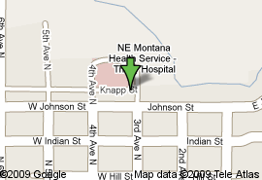

**General Information**

Standard cost for self-pay mammogram $250.00

Usual wait for a screening mammogram Same day

Do patients need to provide a referral No

Type of mammography machines Digital

Radiologist On-site Part-time

**Facility Access Information**

**Van Accessible Parking Yes**

**Standard Accessible Parking Yes**

**Accessible Exterior Route Yes**

Accessible path Yes

Accessible doors Yes

**Accessible Interior Route Yes**

**Accessible Mammography Room No**

Accessible doors Yes

Accessible route and maneuvering space No

Lowest height of x-ray plate from floor 23 inches

**Accessible Restroom on Same Floor Yes**

Accessible route and turning space Yes

Accessible toilet, fixtures and sink Yes

**Language/Alternative Communication**

**Spoken:** English

**Printed:** English

**Video**: None

**Braille:** No

**Large Print:** No

**Sign Language:** No

**Additional Service**

* Accepts Medicaid Patients
* Accepts Medicare Patients
* Diagnostic Mammograms
* CT
* Ultrasound/Sonogram
* Chemotherapy
* Offers other types of Transportation
* Elder Care

**Note**: The available information was gathered spring 2015. Some features including costs, may have changed. Please call the facility for current information.

When scheduling an appointment, notify the facility if you require accommodations.

Keys to symbols: ✝ Radiologist and/or Computer Assisted Device charges not included.



**Northern Montana Hospital**

**406-262-1218**

30 13th Street

Havre, MT 59501

**Hours: 8:30AM-3:30PM**

www.nmhcare.org

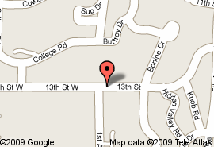

**General Information**

Standard cost for self-pay mammogram $279.00 ✝✝

Usual wait for a screening mammogram 2 weeks

Do patients need to provide a referral Yes

Type of mammography machines Digital

Radiologist On-site Full-time

**Facility Access Information**

**Van Accessible Parking Yes**

**Standard Accessible Parking Yes**

**Accessible Exterior Route Yes**

Accessible path Yes

Accessible doors Yes

**Accessible Interior Route Yes**

**Accessible Mammography Room Yes**

Accessible doors Yes

Accessible route and maneuvering space Yes

Lowest height of x-ray plate from floor 24 inches

**Accessible Restroom on Same Floor Yes**

Accessible route and turning space No

Accessible toilet, fixtures and sink Yes

**Language/Alternative Communication**

**Spoken:** English

**Printed:** English

**Video**: None

**Braille:** No

**Large Print:** No

**Sign Language:** No

**Additional Service**

* Accepts Medicaid Patients
* Accepts Medicare Patients
* Diagnostic Mammograms
* CT, MRI
* Ultrasound/Sonogram
* Stereotactic Biopsy
* Chemotherapy
* Physical Therapy
* Clinical Trials
* Radiation Therapy
* Tumor Board
* Tumor Registry
* Grief and Bereavement
* Nutrition Therapies
* Breast Prosthetics
* Post-Operative Apparel
* Scarves, Wigs, Turbans
* Home Care/Hospice
* Referral Services

**Note**: The available information was gathered spring 2015. Some features including costs, may have changed. Please call the facility for current information.

When scheduling an appointment, notify the facility if you require accommodations.

Keys to symbols: ✝✝ Interpretation fee included.



**Phillips County Hospital & Family Health Clinic**

**406-654-1800**

311 South 8th Avenue East

Malta, MT 59538

**Hours: 8:00AM-5:00PM; M-F**

[www.pchospital.us](http://www.pchospital.us)

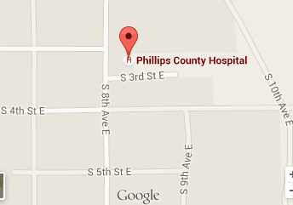

**General Information**

Standard cost for self-pay mammogram $270.00 ✝

Usual wait for a screening mammogram 1-4 weeks

Do patients need to provide a referral Yes

Type of mammography machines Digital

Radiologist On-site No

Contract Radiologist Yes

**Facility Access Information**

**Van Accessible Parking No**

**Standard Accessible Parking Yes**

**Accessible Exterior Route Yes**

Accessible path Yes

Accessible doors Yes

**Accessible Interior Route Yes**

**Accessible Mammography Room Yes**

Accessible doors Yes

Accessible route and maneuvering space Yes

Lowest height of x-ray plate from floor 27 inches

**Accessible Restroom on Same Floor No**

Accessible route and turning space Yes

Accessible toilet, fixtures and sink No

**Language/Alternative Communication**

**Spoken:** English, Spanish

**Printed:** English

**Video**: None

**Braille:** No

**Large Print:** No

**Sign Language:** No

**Additional Service**

* Accepts Medicaid Patients
* Accepts Medicare Patients
* Diagnostic Mammograms
* Ultrasound/Sonogram
* Physical Therapy
* Patient Information and Education
* Second Opinion
* Transportation Services
* Home Care

**Note**: The available information was gathered spring 2015. Some features including costs, may have changed. Please call the facility for current information.

When scheduling an appointment, notify the facility if you require accommodations.

Keys to symbols: ✝ Radiologist and/or Computer Assisted Device charges not included.



**Polson Health**

**406-883-3200**

106 Ridgewater Drive

Polson, MT 59860

**Hours: Varies**

The Winkley Women’s Center is a mobile coach that provides mammography, breast ultrasound and bone density testing in 10 Montana communities including Browning, Chester, Choteau, Conrad, Cut Bank, Eureka, Fort Benton, Kalispell, Polson, Malta, and Plains.

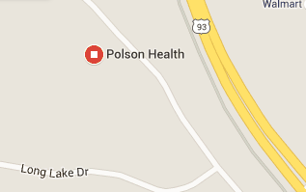

**General Information**

Standard cost for self-pay mammogram Site Specific

***\*Call site for pricing***

Usual wait for a screening mammogram Unknown

Do patients need to provide a referral Unknown

Type of mammography machines Digital

Radiologist On-site No

Contract Radiologist Yes

**Facility Access Information**

**Van Accessible Parking Yes**

**Standard Accessible Parking Yes**

**Accessible Exterior Route Yes**

Accessible path Yes

Accessible doors Yes

**Accessible Interior Route Yes**

**Accessible Mammography Room Yes**

Accessible doors Yes

Accessible route and maneuvering space Yes

Lowest height of x-ray plate from floor 27 inches

**Accessible Restroom on Same Floor No**

Accessible route and turning space Yes

Accessible toilet, fixtures and sink No

**Language/Alternative Communication**

**Spoken:** English

**Printed:** English

**Video**: None

**Braille:** No

**Large Print:** No

**Sign Language:** No

**Additional Service**

* Diagnostic Mammograms
* Ultrasound/Sonogram
* DXA

**Note**: The available information was gathered spring 2015. Some features including costs, may have changed. Please call the facility for current information.

When scheduling an appointment, notify the facility if you require accommodations.

Keys to symbols: ✝ Radiologist and/or Computer Assisted Device charges not included.



**Pondera Medical Center**

**406-271-3211**

805 Sunset Boulevard

Conrad, MT 59425

**Hours: 8:00AM-5:00PM; Varies**

[www.ponderamedical.com](http://www.pchospital.us)

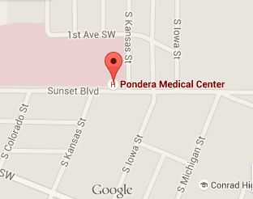

**General Information**

Standard cost for self-pay mammogram $258.00

Usual wait for a screening mammogram 1 week

Do patients need to provide a referral Yes

Type of mammography machines Digital

Radiologist On-site No

Contract Radiologist Yes

**Facility Access Information**

**Van Accessible Parking Unknown**

**Standard Accessible Parking Unknown**

**Accessible Exterior Route Unknown**

Accessible path Unknown

Accessible doors Unknown

**Accessible Interior Route Yes**

**Accessible Mammography Room Yes**

Accessible doors Yes

Accessible route and maneuvering space Yes

Lowest height of x-ray plate from floor 27 inches

**Accessible Restroom on Same Floor Unknown**

Accessible route and turning space Unknown

Accessible toilet, fixtures and sink Unknown

**Language/Alternative Communication**

**Spoken:** English

**Printed:** English

**Video**: None

**Braille:** No

**Large Print:** No

**Sign Language:** No

**Additional Service**

* Free Screening Mammograms
* Accepts Medicaid Patients
* Accepts Medicare Patients
* Diagnostic Mammograms
* CT
* Biopsy
* Ultrasound/Sonogram
* Breast Self-Exam Training
* Referral Services
* Transportation Services
* Hospice

**Note**: The available information was gathered spring 2015. Some features including costs, may have changed. Please call the facility for current information.

When scheduling an appointment, notify the facility if you require accommodations.

Keys to symbols: ✝ Radiologist and/or Computer Assisted Device charges not included.



**St. Vincent Mobile**

**Clinic site: Rosebud Health Care Center**

**406-237-4373**

383 North 17th Avenue

Forsyth, MT 59327

**Hours: 8:00AM-4:00PM; M-F Monthly**

[www.rosebudhealthcare.com](http://www.rosebudhealthcare.com)

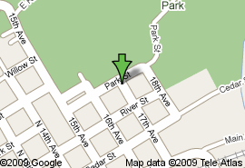

**General Information**

Standard cost for self-pay mammogram $168.50 ✝

Usual wait for a screening mammogram Varies

Do patients need to provide a referral Yes

Type of mammography machines Digital

Radiologist On-site No

Contract Radiologist Yes

**Facility Access Information**

***Disability Access Information: The St. Vincent Mobile Coach does not have an accessible entrance; however, Rosebud Health Care provides entrance, standard parking, and restroom access.***

**Van Accessible Parking No**

**Standard Accessible Parking Yes**

**Accessible Exterior Route Yes**

Accessible path Yes

Accessible doors Yes

**Accessible Interior Route Yes**

**(Clinic Site)**

**Accessible Mammography Room No**

Accessible doors No

Accessible route and maneuvering space No

Lowest height of x-ray plate from floor Unknown

**Accessible Restroom on Same Floor Yes**

Accessible route and turning space Yes

Accessible toilet, fixtures and sink Yes

**Language/Alternative Communication**

**Spoken:** English

**Printed:** None

**Video**: None

**Braille:** No

**Large Print:** No

**Sign Language:** No

**Additional Service**

* Diagnostic Mammograms
* Ultrasound/Sonogram
* Magnetic Resonance Imaging (MRI)
* Stereotactic Needle Biopsy
* Breast Self-Exam Training Pamphlet

**Note**: The available information was gathered spring 2015. Some features including costs, may have changed. Please call the facility for current information.

When scheduling an appointment, notify the facility if you require accommodations.

Keys to symbols: ✝ Radiologist and/or Computer Assisted Device charges not included.



**St. James Healthcare Imaging Services**

**406-496-3535**

435 South Crystal Street

Butte, MT 59701

**Hours: 8:00AM-5:00PM**

[www.stjameshealthcare.org](http://www.stjameshealthcare.org)

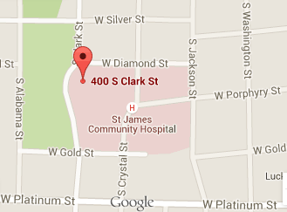

**General Information**

Standard cost for self-pay mammogram $295.00

Usual wait for a screening mammogram 1 week

Do patients need to provide a referral No

Type of mammography machines Digital

Radiologist On-site Full-time

**Facility Access Information**

**Van Accessible Parking Yes**

**Standard Accessible Parking Yes**

**Accessible Exterior Route Yes**

Accessible path Yes

Accessible doors Yes

**Accessible Interior Route No**

**Accessible Mammography Room No**

Accessible doors No

Accessible route and maneuvering space Yes

Lowest height of x-ray plate from floor 25 inches

**Accessible Restroom on Same Floor No**

Accessible route and turning space Yes

Accessible toilet, fixtures and sink No

**Language/Alternative Communication**

**Spoken:** English, Spanish

**Printed:** English

**Video**: English

**Braille:** No

**Large Print:** No

**Sign Language:** Yes

**Additional Service**

* Reduced Rate Screening Mammograms
* Free Screening Mammograms
* Accepts Medicaid Patients
* Accepts Medicare Patients
* Diagnostic Mammograms
* CT
* Stereotactic Biopsy
* Ultrasound/Sonogram
* Breast Self-Exam Training
* Located on a Bus Route

**Note**: The available information was gathered spring 2015. Some features including costs, may have changed. Please call the facility for current information.

When scheduling an appointment, notify the facility if you require accommodations.

Keys to symbols: ✝ Radiologist and/or Computer Assisted Device charges not included.



**Providence St. Joseph Medical Center**

**406-883-8402 or TTY 866-344-2273**

6 13th Avenue East

Polson, MT 59860

**Hours: 7:30AM-4:30PM**

[www.saintjoes.org](http://www.saintjoes.org)

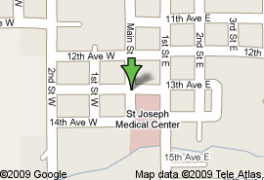

**General Information**

Standard cost for self-pay mammogram $185.00

Usual wait for a screening mammogram 1 day

Do patients need to provide a referral Yes

Type of mammography machines Digital

Radiologist On-site Part-time

**Facility Access Information**

**Van Accessible Parking No**

**Standard Accessible Parking No**

**Accessible Exterior Route Yes**

Accessible path Yes

Accessible doors Yes

**Accessible Interior Route Yes**

**Accessible Mammography Room No**

Accessible doors No

Accessible route and maneuvering space Yes

Lowest height of x-ray plate from floor 26 inches

**Accessible Restroom on Same Floor No**

Accessible route and turning space No

Accessible toilet, fixtures and sink No

**Language/Alternative Communication**

**Spoken:** English, Spanish

**Printed:** English

**Video**: English

**Braille:** No

**Large Print:** English

**Sign Language:** No

**Additional Service**

* Free Screening Mammograms
* Accepts Medicaid Patients
* Accepts Medicare Patients
* Diagnostic Mammograms
* Ultrasound/Sonogram
* Breast Self-Exam Training
* Breast Care Navigator
* Information on Internet
* Home Care
* Chemotherapy
* Cancer Support Group
* Referral Services
* Located on a Bus Route

**Note**: The available information was gathered spring 2015. Some features including costs, may have changed. Please call the facility for current information.

When scheduling an appointment, notify the facility if you require accommodations.

Keys to symbols: ✝ Radiologist and/or Computer Assisted Device charges not included.



**St. Luke Community Healthcare**

**406-676-4441**

107 6th Avenue Southwest

Ronan, MT 59864

**Hours:**

**Monday, Tuesday 7:30AM-9:00PM**

**Thursday, Friday 8:00AM-5:30PM**

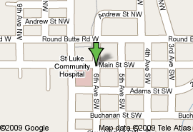

**General Information**

Standard cost for self-pay mammogram $182.40

Usual wait for a screening mammogram Same Day

Do patients need to provide a referral Yes

Type of mammography machines Film

Radiologist On-site Part-time

**Facility Access Information**

**Van Accessible Parking Yes**

**Standard Accessible Parking Yes**

**Accessible Exterior Route Yes**

Accessible path Yes

Accessible doors Yes

**Accessible Interior Route Yes**

**Accessible Mammography Room Yes**

Accessible doors Yes

Accessible route and maneuvering space Yes

Lowest height of x-ray plate from floor 16 inches

**Accessible Restroom on Same Floor Yes**

Accessible route and turning space Yes

Accessible toilet, fixtures and sink Yes

**Language/Alternative Communication**

**Spoken:** English, Spanish

**Printed:** English

**Video**: None

**Braille:** No

**Large Print:** No

**Sign Language:** Yes

**Additional Service**

* Free Screening Mammograms
* Accepts Medicaid Patients
* Accepts Medicare Patients
* Diagnostic Mammograms
* Ultrasound/Sonogram
* Biopsy
* Physical Therapy
* Breast Self-Exam Training
* Referral Services
* Offer Transportation Services

**Note**: The available information was gathered spring 2015. Some features including costs, may have changed. Please call the facility for current information.

When scheduling an appointment, notify the facility if you require accommodations.

Keys to symbols: ✝ Radiologist and/or Computer Assisted Device charges not included.



**St. Peter’s Maria Dean Hospital**

**406-442-2480**

2475 Broadway

Helena, MT 59601

**Hours: 6:30AM-6:00PM**

[www.stpetes.org](http://www.stpetes.org)

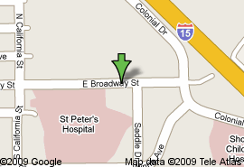

**General Information**

Standard cost for self-pay mammogram $227.00 ✝

Usual wait for a screening mammogram 1 week

Do patients need to provide a referral No

Type of mammography machines Digital

Radiologist On-site Full-time

**Facility Access Information**

**Van Accessible Parking No**

**Standard Accessible Parking Yes**

**Accessible Exterior Route Yes**

Accessible path Yes

Accessible doors Yes

**Accessible Interior Route Yes**

**Accessible Mammography Room Yes**

Accessible doors Yes

Accessible route and maneuvering space Yes

Lowest height of x-ray plate from floor 26 inches

**Accessible Restroom on Same Floor Yes**

Accessible route and turning space Yes

Accessible toilet, fixtures and sink Yes

**Language/Alternative Communication**

**Spoken:** English, Spanish, Interpreters

**Printed:** English

**Video**: English

**Braille:** No

**Large Print:** English

**Sign Language:** Yes

**Additional Service**

* Reduced Rate Screening Mammograms
* Offers Free Screening
* Accepts Medicaid Patients
* Accepts Medicare Patients
* Diagnostic Mammograms
* CT, MRI, PET Scan
* Stereotactic Needle Biopsy
* Ultrasound/Sonogram
* Breast Health Coordinator
* Breast Cancer Group
* Family Cancer Group
* Grief and Bereavement
* Spiritual
* Home Care/Hospice
* Chemotherapy
* Physical Therapy
* Radiation Therapy
* Stem Cell Rescue
* Tumor Board
* Tumor Registry
* Clinical Trials
* Nutrition Therapies
* Breast Prosthetics
* Wigs
* Offer Transportation Services

**Note**: The available information was gathered spring 2015. Some features including costs, may have changed. Please call the facility for current information.

When scheduling an appointment, notify the facility if you require accommodations.

Keys to symbols: ✝ Radiologist and/or Computer Assisted Device charges not included.



**Sheridan Memorial Hospital**

**406-765-3739**

44 West Laurel Avenue

Plentywood, MT 59254

**Hours: 8:00AM-5:00PM**

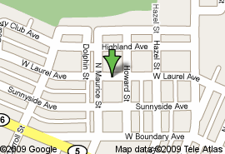

**General Information**

Standard cost for self-pay mammogram $120.00 ✝

Usual wait for a screening mammogram <1 week

Do patients need to provide a referral No

Type of mammography machines Digital

Radiologist On-site No

Contract Radiologist Yes

**Facility Access Information**

**Van Accessible Parking No**

**Standard Accessible Parking Yes**

**Accessible Exterior Route Yes**

Accessible path Yes

Accessible doors Yes

**Accessible Interior Route Yes**

**Accessible Mammography Room No**

Accessible doors No

Accessible route and maneuvering space Yes

Lowest height of x-ray plate from floor 11 inches

**Accessible Restroom on Same Floor No**

Accessible route and turning space No

Accessible toilet, fixtures and sink No

**Language/Alternative Communication**

**Spoken:** English

**Printed:** English, Spanish

**Video**: English

**Braille:** No

**Large Print:** No

**Sign Language:** No

**Additional Service**

* Accepts Medicaid Patients
* Accepts Medicare Patients
* Reduced Rate Screening Mammograms
* Free Screening Mammograms
* Diagnostic Mammograms
* CT
* Ultrasound/Sonogram
* Physical Therapy
* Breast Self-Exam Training
* Breast Cancer Navigator
* Family Cancer Group
* Grief and Bereavement
* Home Care/Hospice
* Offer Transportation Services

**Note**: The available information was gathered spring 2015. Some features including costs, may have changed. Please call the facility for current information.

When scheduling an appointment, notify the facility if you require accommodations.

Keys to symbols: ✝ Radiologist and/or Computer Assisted Device charges not included.



**Sidney Health Center**

**800-488-2100**

216 14th Avenue Southwest

Sidney, MT 59270

**Hours: 8:00AM-4:30PM; M-F**

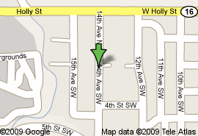

**General Information**

Standard cost for self-pay mammogram $343.00

Usual wait for a screening mammogram 2-3 days

Do patients need to provide a referral Yes

Type of mammography machines Digital

Radiologist On-site Full-time

**Facility Access Information**

**Van Accessible Parking Yes**

**Standard Accessible Parking Yes**

**Accessible Exterior Route Yes**

Accessible path Yes

Accessible doors Yes

**Accessible Interior Route Yes**

**Accessible Mammography Room Yes**

Accessible doors Yes

Accessible route and maneuvering space Yes

Lowest height of x-ray plate from floor 24 inches

**Accessible Restroom on Same Floor Yes**

Accessible route and turning space Yes

Accessible toilet, fixtures and sink Yes

**Language/Alternative Communication**

**Spoken:** English

**Printed:** English

**Video**: English

**Braille:** No

**Large Print:** No

**Sign Language:** No

**Additional Service**

* Accepts Medicaid Patients
* Accepts Medicare Patients
* Diagnostic Mammograms
* CT
* Ultrasound/Sonogram
* Needle Biopsy
* Physical Therapy
* Chemotherapy
* Breast Self-Exam Training
* Family Cancer Group
* Grief and Bereavement
* Spiritual
* Home Care/Hospice
* Referral Services
* Nutrition Therapies
* Wigs/Hairpieces

**Note**: The available information was gathered spring 2015. Some features including costs, may have changed. Please call the facility for current information.

When scheduling an appointment, notify the facility if you require accommodations.

Keys to symbols: ✝ Radiologist and/or Computer Assisted Device charges not included.



**Stillwater Community Hospital**

**406-322-1000**

710 North 11th Street

Columbus, MT 59019

**Hours: 7:30AM-5:00PM**

**Mammograms: 10:00AM-4:00PM**

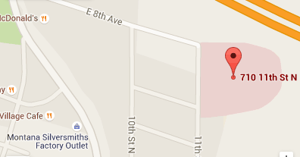

**General Information**

Standard cost for self-pay mammogram $310.00 ✝

Usual wait for a screening mammogram >1 week

Do patients need to provide a referral No

Type of mammography machines Digital

Radiologist On-site No

Contract Radiologist Yes

**Facility Access Information**

**Van Accessible Parking No**

**Standard Accessible Parking No**

**Accessible Exterior Route No**

Accessible path No

Accessible doors No

**Accessible Interior Route Yes**

**Accessible Mammography Room Yes**

Accessible doors Yes

Accessible route and maneuvering space Yes

Lowest height of x-ray plate from floor 16 inches

**Accessible Restroom on Same Floor No**

Accessible route and turning space Yes

Accessible toilet, fixtures and sink No

**Language/Alternative Communication**

**Spoken:** English

**Printed:** English

**Video**: None

**Braille:** No

**Large Print:** No

**Sign Language:** No

**Additional Service**

* Reduced Rate Screening Mammograms
* Offers Free Screening
* Accepts Medicaid Patients
* Accepts Medicare Patients
* Diagnostic Mammograms
* Home Care
* Pamphlets
* Offer Transportation Services

**Note**: The available information was gathered spring 2015. Some features including costs, may have changed. Please call the facility for current information.

When scheduling an appointment, notify the facility if you require accommodations.

Keys to symbols: ✝ Radiologist and/or Computer Assisted Device charges not included.



**Teton Medical Center**

**406-466-5763**

915 4th Street Northwest

Choteau, MT 59422

**Hours: 8:30AM-4:00PM; M-F**

**(Bi-Monthly)**

[www.tetonmedicalcenter.net](http://www.tetonmedicalcenter.net)

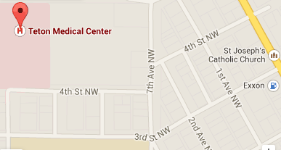

**General Information**

Standard cost for self-pay mammogram $202.00

Usual wait for a screening mammogram 2 weeks

Do patients need to provide a referral Yes

Type of mammography machines Digital

Radiologist On-site No

Contract Radiologist Yes

**Facility Access Information**

**Van Accessible Parking Unknown**

**Standard Accessible Parking Unknown**

**Accessible Exterior Route Unknown**

Accessible path No

Accessible doors No

**Accessible Interior Route Unknown**

**Accessible Mammography Room Unknown**

Accessible doors No

Accessible route and maneuvering space No

Lowest height of x-ray plate from floor 27 inches

**Accessible Restroom on Same Floor Unknown**

Accessible route and turning space No

Accessible toilet, fixtures and sink No

**Language/Alternative Communication**

**Spoken:** English, Spanish

**Printed:** English

**Video**: None

**Braille:** No

**Large Print:** No

**Sign Language:** No

**Additional Service**

* Accepts Medicaid Patients
* Accepts Medicare Patients
* Diagnostic Mammograms
* Ultrasound/Sonogram
* DXA

**Note**: The available information was gathered spring 2015. Some features including costs, may have changed. Please call the facility for current information.

When scheduling an appointment, notify the facility if you require accommodations.

Keys to symbols: ✝ Radiologist and/or Computer Assisted Device charges not included.



**Wheatland Memorial Health**

**406-632-3119**

530 3rd Street Northwest

Harlowton, MT 59036

**Hours: 8:30AM-5:00PM**

[www.wheatlandmemorial.org](http://www.wheatlandmemorial.org)

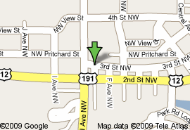

**General Information**

Standard cost for self-pay mammogram $210.00

Usual wait for a screening mammogram 1-2 days

Do patients need to provide a referral No

Type of mammography machines Digital

Radiologist On-site No

Contract Radiologist Yes

**Facility Access Information**

**Van Accessible Parking No**

**Standard Accessible Parking No**

**Accessible Exterior Route No**

Accessible path No

Accessible doors No

**Accessible Interior Route Yes**

**Accessible Mammography Room Yes**

Accessible doors Yes

Accessible route and maneuvering space Yes

Lowest height of x-ray plate from floor 11 inches

**Accessible Restroom on Same Floor No**

Accessible route and turning space No

Accessible toilet, fixtures and sink No

**Language/Alternative Communication**

**Spoken:** English

**Printed:** English

**Video**: English

**Braille:** English

**Large Print:** No

**Sign Language:** No

**Additional Service**

* Reduced Rate Screening Mammograms
* Accepts Medicaid Patients
* Accepts Medicare Patients
* Diagnostic Mammograms
* Ultrasound/Sonogram
* CT
* Breast Self-Exam Training

**Note**: The available information was gathered spring 2015. Some features including costs, may have changed. Please call the facility for current information.

When scheduling an appointment, notify the facility if you require accommodations.

Keys to symbols: ✝ Radiologist and/or Computer Assisted Device charges not included.



**Winkley Women’s Center**

(Mobile)

**406-751-9729**

Based at 320 Sunnyview Lane

Kalispell, MT 59901

**Hours: Varies – Usually 8:30AM-4:30PM**

The Winkley Women’s Center is a mobile coach that provides mammography, breast ultrasound and bone density testing in 10 Montana communities including Browning, Chester, Choteau, Conrad, Cut Bank, Eureka, Fort Benton, Kalispell, Polson, Malta, and Plains. ***To schedule an appointment, please contact the healthcare facility nearest you.***

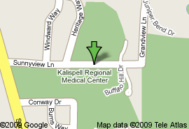

**General Information**

Standard cost for self-pay mammogram Site Specific

***\*Call site for pricing***

Usual wait for a screening mammogram 2 weeks

Do patients need to provide a referral Unknown

Type of mammography machines Digital

Radiologist On-site No

Contract Radiologist Yes

**Facility Access Information**

**Van Accessible Parking**

**Standard Accessible Parking**

**Accessible Exterior Route**

*Note: Items above are site specific.*

**Accessible Interior Route Yes**

**Accessible Mammography Room Yes**

Accessible doors Yes

Accessible route and maneuvering space Yes

Lowest height of x-ray plate from floor 27 inches

**Accessible Restroom on Same Floor No**

*Note: Patients use the facility’s restrooms.*

**Language/Alternative Communication**

**Spoken:** English

**Printed:** English

**Video**: None

**Braille:** No

**Large Print:** No

**Sign Language:** No

**Additional Service**

* Diagnostic Mammograms
* Ultrasound/Sonogram
* DXA

**Note**: The available information was gathered spring 2015. Some features including costs, may have changed. Please call the facility for current information.

When scheduling an appointment, notify the facility if you require accommodations.

Keys to symbols: ✝ Radiologist and/or Computer Assisted Device charges not included.



**The Women’s Center at Healthcare Northwest**

**406-751-9729**

320 Sunnyview Lane

Kalispell, MT 59901

**Hours: 7:30AM-5:30PM**



**General Information**

Standard cost for self-pay mammogram $201.00 ✝

Usual wait for a screening mammogram <1 week

Do patients need to provide a referral No

Type of mammography machines Digital

Radiologist On-site Full-time

**Facility Access Information**

**Van Accessible Parking No**

**Standard Accessible Parking Yes**

**Accessible Exterior Route Yes**

Accessible path Yes

Accessible doors Yes

**Accessible Interior Route Yes**

**Accessible Mammography Room Yes**

Accessible doors Yes

Accessible route and maneuvering space Yes

Lowest height of x-ray plate from floor 26 inches

**Accessible Restroom on Same Floor Yes**

Accessible route and turning space Yes

Accessible toilet, fixtures and sink Yes

**Language/Alternative Communication**

**Spoken:** English, Spanish, Other

**Printed:** English, Spanish

**Video**: None

**Braille:** No

**Large Print:** English, Spanish

**Sign Language:** Yes

**Additional Service**

* Reduced Rate Screening Mammograms
* Accepts Medicaid Patients
* Accepts Medicare Patients
* Breast Self-Exam Training
* Information on the Internet
* Breast Cancer Patient Navigator
* Diagnostic Mammograms
* CT, MRI, PET Scan
* Ultrasound/Sonogram
* Stereotactic Biopsy
* Chemotherapy
* Physical Therapy
* Radiation Therapy
* Tumor Board
* Tumor Registry
* Breast Reconstruction
* Breast Prosthetics
* Cancer Support Group
* Genetic Risk
* Home Care/Hospice
* Located on a Bus Route
* Offers Transportation Services
* Referral Services

**Note**: The available information was gathered spring 2015. Some features including costs, may have changed. Please call the facility for current information.

When scheduling an appointment, notify the facility if you require accommodations.

Keys to symbols: ✝ Radiologist and/or Computer Assisted Device charges not included.



**Yellowstone Breast Center**

**406-237-4252**

2900 12th Avenue North Suite 276

Billings, MT 59101

**Hours: 8:00AM-4:00PM; M-F Monthly**

[www.svh-mt.org](http://www.svh-mt.org)

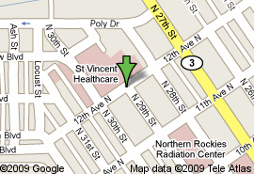

**General Information**

Standard cost for self-pay mammogram $168.50 ✝

Usual wait for a screening mammogram Varies

Do patients need to provide a referral Yes

Type of mammography machines Digital

Radiologist On-site Full-time

Contract Radiologist Yes

**Facility Access Information**

***Disability Access Information: The St. Vincent Mobile Coach does not have an accessible entrance; however, Rosebud Health Care provides entrance, standard parking, and restroom access.***

**Van Accessible Parking Yes**

**Standard Accessible Parking Yes**

**Accessible Exterior Route Yes**

Accessible path Yes

Accessible doors Yes

**Accessible Interior Route Yes**

(Clinic Site)

**Accessible Mammography Room No**

Accessible doors No

Accessible route and maneuvering space No

Lowest height of x-ray plate from floor Unknown

**Accessible Restroom on Same Floor No**

Accessible route and turning space No

Accessible toilet, fixtures and sink No

**Language/Alternative Communication**

**Spoken:** English

**Printed:** English

**Video**: None

**Braille:** No

**Large Print:** No

**Sign Language:** No

**Additional Service**

* Diagnostic Mammograms
* MRI
* Ultrasound/Sonogram
* Stereotactic Needle Biopsy
* Breast Cancer Group
* Family Cancer Group
* Genetic Risk
* Grief and Bereavement
* Spiritual
* Breast Cancer Patient Navigator

**Note**: The available information was gathered spring 2015. Some features including costs, may have changed. Please call the facility for current information.

When scheduling an appointment, notify the facility if you require accommodations.

Keys to symbols: ✝ Radiologist and/or Computer Assisted Device charges not included.

