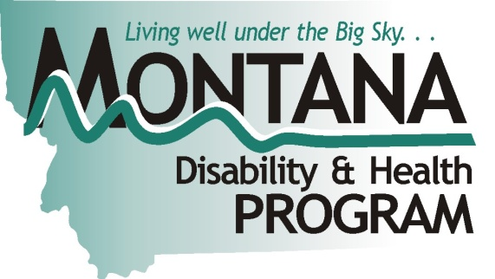
Access to Rural Health Clinics and Community Health Centers
About one out of five people in the United States lives with some type of disability, including physical, vision, mental health, cognitive, intellectual and developmental disabilities, and other health conditions that cause limitations in one or more major life activities. In 2010, persons with disabilities self-rated their overall health as fair/poor (39.5%), indicating a substantial lower quality of health compared to persons without disabilities (8.7%) (Centers for Disease Control and Prevention, 2011).
Accessibility Ambassadors from one of the four centers of Montana Independent Living conducted assessments on-site of rural health clinics (RHC) and community health centers (CHC) to evaluate accessibility in four priority areas: accessible approach and entrance, access to goods and services, accessible rest room, and additional access (e.g., accessible telephone, drinking fountain). The apparatus used to conduct the assessment was the Massachusetts Facility Assessment Tool (MFAT) which provides ADA standards of accessibility characteristics of a RHC, or CHC, for persons with disabilities. Forty-seven RHCs and CHCs participated in this project. The MFAT results indicated not one RHC, or CHC met all ADA standards. The Accessibility Action Plan is provided to each RHC and CHC, lists the barriers that are present, provides details about specific barriers, and suggests some possible solutions. Subsequent columns prompt assignment of a “timeline” and “responsible party” for implementing solutions. Finally, there is a “progress” column to record the facility's accomplishments in addressing each defined barrier. Some barriers will require minimal efforts to address, while other solutions may be integrated into long-term strategic plans.
The Montana Disability and Health Program (MTDH) has been collecting satisfaction surveys about the effectiveness of accessibility assessments on increasing accessibility of health care facilities. Here is one testimony:

It has been a pleasure to work with you. We were able to incorporate your entire list of ADA needs for our Alder Building into our Capital Development Facility Improvement grant to HRSA. We received that grant funding and will be able to incorporate those ADA improvements in our remodel. We care about accessibility – it is in our mission statement.

~ Kim Mansch, Partnership Health Center, Inc.
Learning Objectives:
- Demonstrate the health disparity persons with disabilities encounter in seeking medical care.
- Discuss the possible resources for clinics and facilities for improving accessibility features of their building.
- Identify common accessibility barriers based in four priority areas in RHC and CHC buildings.

A primary objective for this project is to promote the availability of funds for increasing the accessibility of Montana health care facilities. The testimony highlights the need to increase awareness of health care facility access barriers for people with disabilities and to provide resources to increase accessibility.
Resources and materials that have been useful to health care facilities and providers for addressing accessibility barriers to receiving health care services are provided to facilities. Currently, Accessibility Ambassadors are conducting follow up meetings with each clinic or facility to determine the progress in removing accessibility barriers. Follow up group forums are highly suggested for taking the next step to receiving specific barriers that persons with disabilities are challenged with in receiving health care.

Contact Information:
Meg Ann Traci, PhD
Montana Disability and Health Program
Meg Ann Traci, PhD
52 Corbin Hall, Missoula, MT 59812
matraci@ruralinstitute.umt.edu
(406) 243-4956
http://mtdh.ruralinstitute.umt.edu/

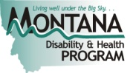
© 2012 RTC:Rural. Opinions expressed are the author’s and do not necessarily reflect those of the funding agency.

