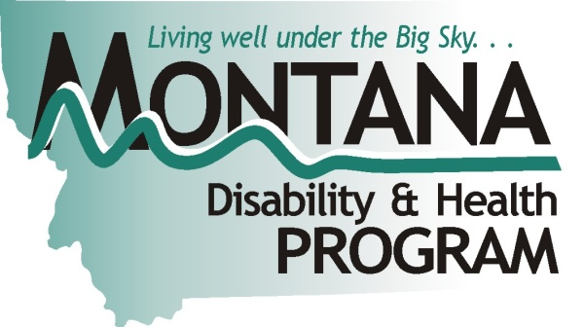
Fitness Professionals Promote Inclusive
Exercise and Physical Activity Statewide
Poor health is a national epidemic among people with disabilities [National Center on Physical Activity and Disability (NCPAD), 2010]. People with disabilities tend to live more sedentary lifestyles and may be at greater risk of developing secondary conditions associated with inactivity. In Montana, approximately one in four adults report limited activity because of physical, mental, or emotional disabilities (Montana Behavioral Risk Factor Surveillance System, 2010).
A viable approach to addressing people's unique needs and situations – particularly for people who have disabilities – is to adapt and modify their fitness and recreation settings and programs.
Health professionals may fail to promote regular physical activity for people with disabilities, perhaps due to a lack of information or training on how to adapt physical activity and exercise programs for people with disabilities.
The Certificate for Inclusive Fitness Training provides the education and skills for fitness professionals to serve people with disabilities. Moreover, fitness professionals can be ‘Champions’ of inclusive fitness in their communities by offering individuals with disabilities the opportunity to be more active and healthy while avoiding secondary conditions associated with their disability.
The Inclusive Fitness Champion Program
was created to educate fitness professionals
in Montana on developing and implementing individualized exercise programs for
individuals with physical, sensory, or cognitive disabilities. In October 2010, the National
“I would never have had the confidence or skills to work with a special needs population without taking the CIFT training.”
~ Kimberly Irlbeck,
Inclusive Fitness Trainer & Champion
Inclusive Fitness Champion Kimberly Irlbeck is now training clients with cerebral palsy, Parkinson’s disease, and cognitive and visual impairments. In addition, she conducted an AIMFREE accessibility assessment at the Summit Medical Fitness Center. After presenting the report to the managers, improvements were made, such as making accessible parking spots level and removing weight benches to make equipment more accessible to members with limited mobility and to wheelchair users.
Graph 1: Participation in Physical Activity

Center on Physical Activity and Disability (NCPAD) presented a free one-day Inclusive Fitness Trainer workshop to 32 fitness professionals. Eligible trainers were able to earn continuing education credits through the American College of Sports Medicine (ACSM) as well as sit for the Certificate for Inclusive Fitness Trainers (CIFT) exam the following day.
The Montana Disability and Health Program (MTDH) offered assistance to recruit and support workshop participants to travel to the workshop. MTDH also made special arrangements with the University of Montana Testing Center to offer the ACSM CIFT exam the following day. Currently, 10 Inclusive Fitness Champions in six counties represent Montana’s five public health planning regions. These champions advocate for inclusive fitness for people with disabilities in their communities.
Outcomes of Inclusive Fitness Champions
- Developed a database of professional fitness trainers in Montana that serves as a tool for MTDH and other organizations to communicate future professional development opportunities and collaborate with other trainers in their communities.
- Supported 10 ACSM/NCPAD Certified Inclusive Fitness Champions in six Montana counties, who advocate for inclusive fitness in their community, to raise awareness of disability health disparities and assess fitness center accessibility needs.
- Conducted fitness center accessibility assessments in three Montana cities that increased upper management’s understanding of the barriers that prevent full inclusion in exercise and physical activity programs, the need for accessible physical activity options for persons with disabilities, and the solutions for accessibility.
- Implemented Able to Be Fit, an exercise class for individuals with disabilities – 10 individuals with disabilities participated in the Spring 2011 class.
- Secured $17,000 in grant funding and scholarship support to assist for financial assistance with personal training costs for people with disabilities and purchased weight supported fitness equipment for one facility in Whitefish. The facility hosted an Open House and a Health Fair to promote the Adapted Exercise Program.
- Conducted a statewide needs assessment of Montana Elementary PE teachers on their self-efficacy toward teaching students with orthopedic impairments as a graduate thesis project.
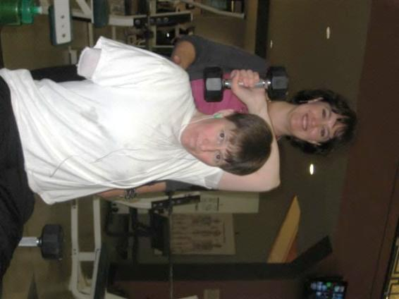
MTDH plans to create a link on our website with information
for professional fitness trainers on how to become an
Inclusive Fitness Champion in their community.
Contact Information:
Montana Disability and Health Program; Meg Ann Traci, PhD;
52 Corbin Hall, Missoula, MT 59812; (406) 243-4956, (888)268-2743,
(406) 243-4200 TTY; matraci@ruralinstitute.umt.edu,
http://mtdh.ruralinstitute.umt.edu/
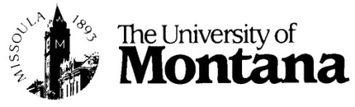
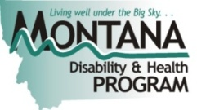
Kimberly Irlbeck works with a client.

